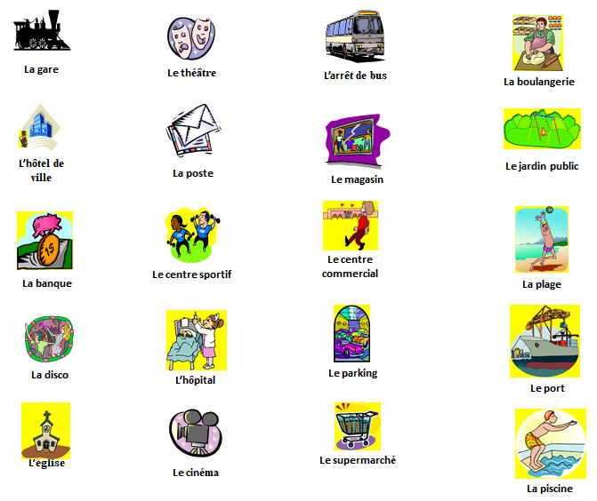
Il y a … There is/are…
(m)
(f)
(m)
(f)
Il y a aussi … There is/are also…
Don’t forget that the needs to change to a or some in sentences
a (masculine)
a (feminine)
some (plural)
le > un
the
la > une
les > des
Il y a un marché There is a market
Il y a une poste There is a post office
Il y a des magasins There is a store
Additional research: What other places can you think of in a town you would like to know the names of? Add a picture and text below. Don’t forget to add the correct word for the according to if the word is masculine or feminine
 | l’école (f)  school
Look at the sentences below. Can you translate them in to English?
Dans ma ville il y a une plage. ______________________________________________________________________
Dans ma ville il y a un supermarché et une banque.
______________________________________________________________________
Look at the sentences below. Can you translate them in to French?
In my town there is a cinema.
______________________________________________________________________
In my town there is a sports centre and a park.
______________________________________________________________________
In my town there is a hospital, a town hall and a post office.
______________________________________________________________________
______________________________________________________________________
Now create your own sentence in French:
______________________________________________________________________
______________________________________________________________________

