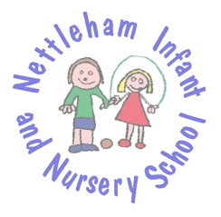
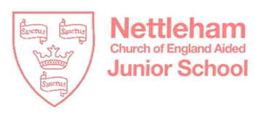

A VIRTUAL BOOK FAIR FOR NETTLEHAM SCHOOL FAMILIES – FEBRUARY 2021
Dear Nettleham Schools Families
We are writing to you as two schools but one Nettleham School family to share with you an exciting new joint project that will, we hope give a great boost to reading across our whole school community, at the same time we are thrilled to be able to support a vibrant local business.
Over the past 12 months, the staff of Nettleham Infant and Nursery School and Nettleham Church of England Aided Junior School have kept in close contact and talked about how we can move forwards with the exciting joint projects that we had initially planned at the start of 2020. It has, obviously, proved more difficult when we have had to remain in our own school and class bubbles.
With this in mind we are delighted to announce our first ‘virtual’ book fair. The staff from both of our schools have carefully chosen ‘recommended reads’ for their classes and we have teamed up with Lincoln’s independent bookshop, Lindum Books to provide them for you in one place.
When you visit Lindum Books’ page on the uk.bookshop.org site you will find two book lists:
Nettleham Infant and Nursery School: https://uk.bookshop.org/lists/nettleham-schools-suggested-reads-infants
Nettleham Junior School: https://uk.bookshop.org/lists/nettleham-schools-suggested-reads-juniors
Please consider buying one or more of the books from the lists for your children. The books are grouped per year group and you can buy them directly through the site. Whilst the order is fulfilled by a national bookselling organisation, your local bookshop will benefit greatly as a result of any orders.
We look forward to our children ‘reading together’ once again even though they are not yet in the same building!
With very best wishes
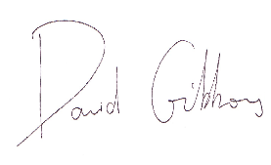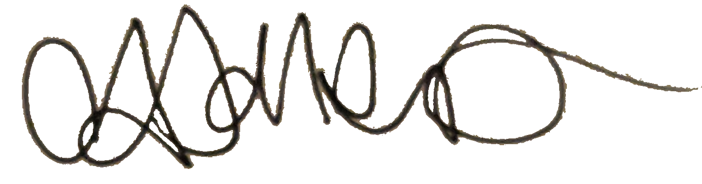
David Gibbons Catherine Jollands
Headteacher Headteacher
Nettleham Church of England Aided Junior School Nettleham Infant and Nursery School

