Church in the Porch
Sunday 21st February – 1st Sunday of Lent

Ready, Steady, Go!

Gospel of Mark
Chapter 1, verses 9-15


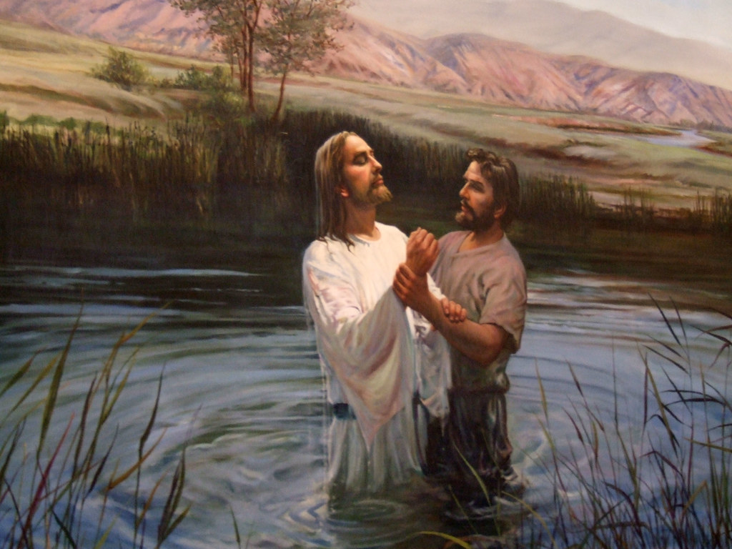

www.asn.church

Our reading from the Gospel this week…
Jesus Is Baptized
At that time Jesus came from the town of Nazareth in Galilee to the place where John was. John baptized Jesus in the Jordan River. When Jesus was coming up out of the water, he saw heaven open. The Holy Spirit came down on him like a dove. A voice came from heaven and said: “You are my Son and I love you. I am very pleased with you.”
Jesus Is Tempted
Then the Spirit sent Jesus into the desert alone. He was in the desert 40 days and was there with the wild animals. While he was in the desert, he was tempted by Satan. Then angels came and took care of Jesus.
Jesus Chooses Some Followers
After John was put in prison, Jesus went into Galilee and preached the Good News from God. Jesus said, “The right time has come. The kingdom of God is near. Change your hearts and lives and believe the Good News!”

Something to think about…
Our gospel story today tells in three very short steps how Jesus prepared to begin his ministry on earth. The writer, who we know as ‘Mark’, was very good at telling stories very quickly!

Today he tells us what Jesus did to get ready – he was baptised in the river Jordan by John. Then he tells us what Jesus did to become steady in his ideas about who he was and what his ministry was going to be – he went into the desert for 40 days and there he was tempted by Satan, but didn’t change his mind about what he had to do. Then finally he decided to go – out into the world and tell everyone about the Kingdom of God and the Good News.

It’s pretty much the same for all of us when we become Christians. First of all we get ready by accepting Jesus as Lord and we might also ask to be baptised as a member of the church. We grow steady in our faith as we learn more about what Jesus did, and how much God loves us. Then we too learn to go out into the world to tell our friends and those we love about God’s Kingdom here on earth.

In all of this we are guided by the Holy Spirit – who Jesus sends to guide us and help us so that we can be more like him. It’s the Holy Spirit inside us that helps us to do good things, and reminds us to say sorry when we do something that hurts someone. It’s the Holy Spirit that helps us feel close to God when we look at a beautiful flower or the night sky and think ‘Wow that’s amazing!’ We often find that we can feel the Holy Spirit with us at times of quietness, when we are just sitting and thinking or sitting and praying. (Our prayer this week might help).

If you want to hear more about how you can be baptised, do get in touch. Carry on reading Church in the Porch to learn more about Jesus and the Kingdom of God, and perhaps come to join us when we are able to go back to our family services, hopefully from Easter. And when you are ready and steady, then you can go and tell!
Rev. Teena

Things to do…
Holy Spirit spinner
The Bible describes how the Holy Spirit comes down on Jesus like a dove. This activity uses an old technique to take 2 pictures and turn them into one by the power of motion. There are other ways of creating this sort of ‘moving picture’, one of which is described below that you might also want to try. But the bits and pieces that you will need for the spinner are included in the resource pack for today.

You will need (*included in the pack)
Card* String*
Scissors and glue Colouring pencils/felt tips

Draw two circles the same size on the card. You can do this easily by drawing round the bottom of a mug or a jar.
Then trace or copy the pictures below onto the circles – one picture on each circle. You need the picture of Jesus to be at the bottom of one circle, and the dove to be at the top of the other.
Take the string and tie the two ends together so that you have a long loop.
Now that you have two separate pictures it is time to make them become one.
Take the first circle and lay it on the table. Then flip it over so that the picture is on the other side (make sure that the picture is still pointing the right way up and not gone sideways or anything!)
Cover the back of the picture with lots of glue.
Lay the loop of string onto the glue on the picture. You want to try and get the middle of the loop into the middle of the picture, so that you have the same amount of string on either side.
Now place the second picture over the top of the first (right way up again!) so that it traps the loop of string in the middle. Press hard all the way round so that the two pictures are definitely stuck together.
Now for the magic bit!
Holding each end of the loop, twist and turn the string so that it tightens up. You will need to turn a different way in each hand.
Then when you have twisted all the string together as much as you can give both ends a tug – and the circle will spin and the two pictures will come together as one!

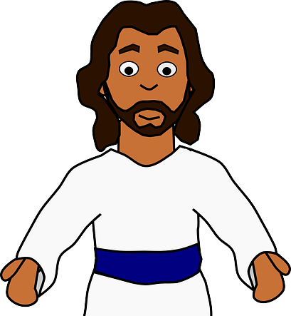



Other ways to make ‘moving pictures’
Take an old note-book and draw a picture on the corner each page, changing the picture slightly on each fresh page. There’s an example given over the next page to have a picture of a growing flower.
Once you have drawn all of your pictures you then flick through the corners of the pages in the book – this is called ‘flip book animation’ and if you Google it you will find lots of other ideas.
One I used to do when I was a little girl was to have a stick man who was running to a house that was half-way up the page!

Did you know…
The reason why we talk about ‘the movies’ is because we are talking about ‘moving pictures’. Over time the words ‘moving pictures’ got changed to be ‘movies’. So when you go to the cinema, what you are watching on screen is just lots and lots of ‘frames’ – still pictures – that are shown super quick one after the other!
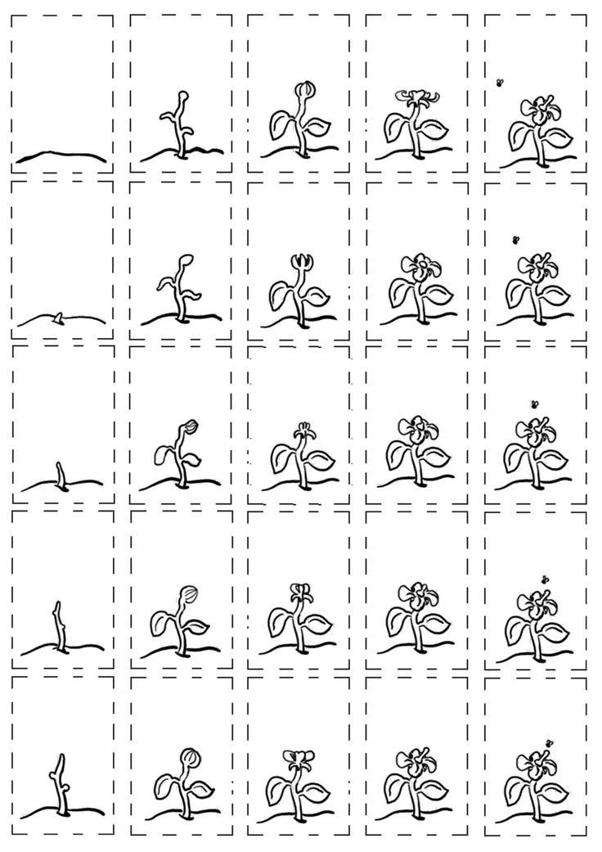
Prayer for this week…
This week the Lent group at church comes to ‘contemplation’ on our Lent course. ‘Contemplation’ is a long word that just means ‘thinking about’. Lent is a time when Christians think deeply about God. Who is God? What is God doing in my life? How do I know that God is with me? Again you can join in too!
If you picked up a CitP bag last week you will have a little battery tealight candle that you can switch on when you are thinking about God. (If you haven’t got one, but would like one then send me an email at teena@asn.church and we’ll get one to you). Here’s the prayer that we are using in church for this week whilst we all do just that:

Be still and know that I am God.
Be still and know that I am.
Be still and know.
Be still.
Be.

Colouring page…
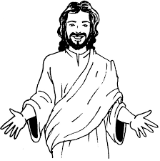
Jesus is Lord!

Services and other offerings from All Saints, Nettleham

From this Sunday we will be in church every Sunday at 10am. We are keeping numbers to a strict few so places are very limited and booking is required every week. You do this by emailing admin@asn.church or ringing the number below. Families and children are always welcome to book into this service – or to join us on our Facebook live feed.

Over the coming weeks, we will continue to supplement our weekly services with resources in our churchyard, the church porch and in the stable. Please do help yourselves to any of the resources that are on offer. Do also keep your eye on our Facebook page and website for more information about what is happening. Our next online services for families are:
Sun 28th February – AllSaintsOnline@4 pic’n’mix online worship

We hope to be able to return to church with a family AllSaints@4 service before Easter. We’d also love to be baptising children (and adults!) in the months afterwards. If you would like to hear more about baptism, communion or faith, or you would like your children to be placed on the list to be baptised in your church or to receive first communion at one of our AllSaints@4 Holy Communion services, please do contact Fr. Richard or Rev. Teena to discuss this.

Get in touch: teena@asn.church / www.asn.church
Office: admin@asn.church or phone 01522 931076
Find us on Facebook: All Saints Nettleham

