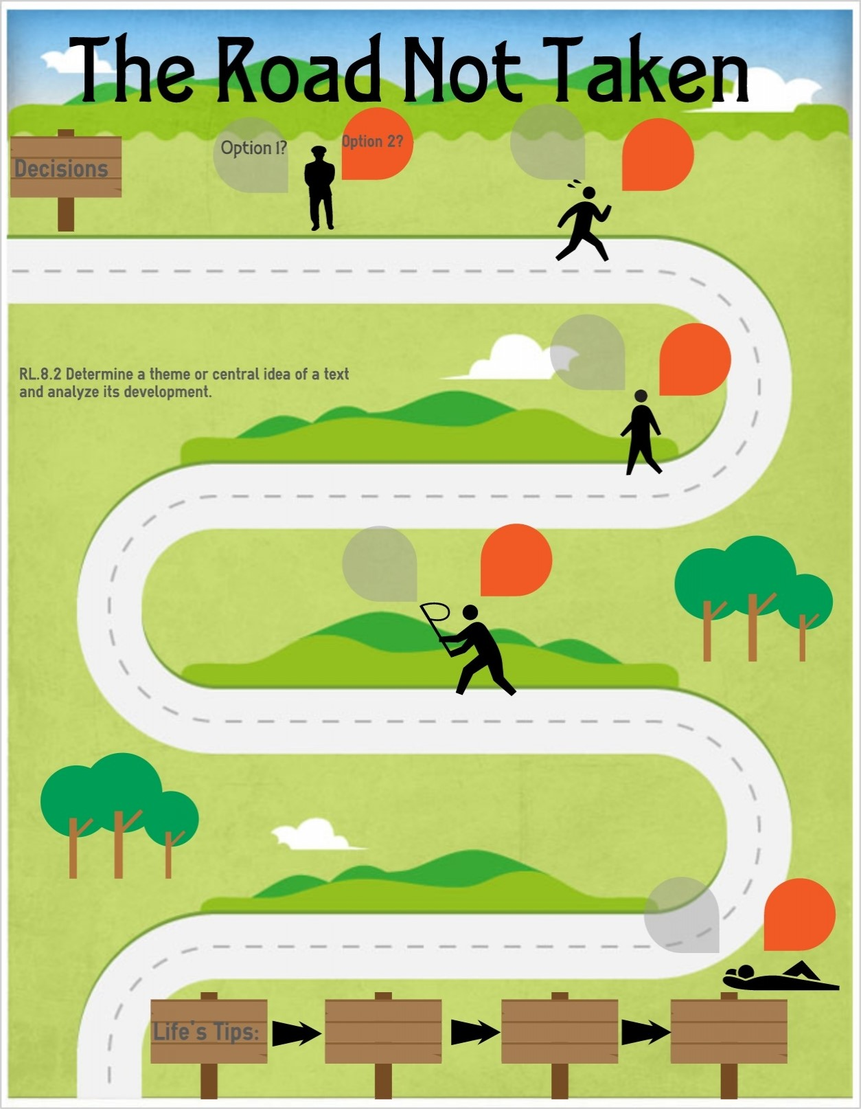
Healthy Eating
Pupils should know…
-what constitutes a healthy diet (including calories and other nutritional content)
-the principles of planning and preparing a range of healthy meals
Identify that animals, including humans need the right types and amount of nutrition, and that they cannot make their own food they get nutrition from what they eat
Nutrition balanced diet/unhealthy diet
Design & make a fruit salad and design and make a farmhouse breakfast to understand the importance of a balanced diet
Mental Wellbeing
Pupils should know…
-that mental wellbeing is a normal part of daily life, in the same way as physical health
-that there is a normal range of emotions (e.g. happiness, sadness, fear, anger, surprise, nervousness) and scale of emotions that all humans experience in relation to different experiences and situations
-how to recognise and talk about their emotions, including having a varied vocabulary of words to use when talking about their own and others; feelings
-how to judge whether what they are feeling and how they are behaving is appropriate and proportionate
-solation and loneliness can affect children and that it is very important for children to discuss their feelings with an adult and seek support
To understand more about resilience through exploring the trials that Jesus went through
That the Easter story involves Christians going through a range of emotions (how do respond to our different emotions)
Physical Health & Fitness
Pupils should know…
-the characteristics and mental and physical benefits of an active lifestyle
-the risks associated with an inactive lifestyle (including obesity)
-how and when to seek support including which adults to speak to in school if they are worried about their health
Can continuously run for over 8 minutes

Health and Prevention
Pupils should know…
- the facts and science relation to allergies, immunisation and vaccination
Explore the requirements of plants for life and growth
Basic First Aid
Pupils should know…
-how to make a clear and efficient call to emergency services if necessary
-concepts of basic first-aid, for example dealing with common injuries including head injuries
St Johns Ambulance Lesson – Bites and stings
St Johns Ambulance Lesson - Emergencies and calling for help

Changing Adolescent Bodies
Pupils should know…
Explore the requirements of plants for life and growth
Drugs, Alcohol and Tobacco
Pupils should know…

PSHE Themes:
(HeartSmart)
-Get HeartSmart

-Don’t forget to let love in!
-Too much selfie isn’t healthy!
-Don’t rub it in, rub it out
-Fake is a mistake

-‘No way through’ isn’t true
Internet Safety and Harms
Pupils should know…
–that people sometimes behave differently online, including by pretending they are someone they are not
–the rules and principles for keeping safe online, how to recognise risks, harmful content and contact, and how to report them
-how information and data is shared online
Cyberbullying
Use technology safely, respectfully and responsibly; recognise acceptable /unacceptable behaviour; identify a range of ways to report concerns about content and contact

YEAR 3 – RSHE Road Map
Health Education

