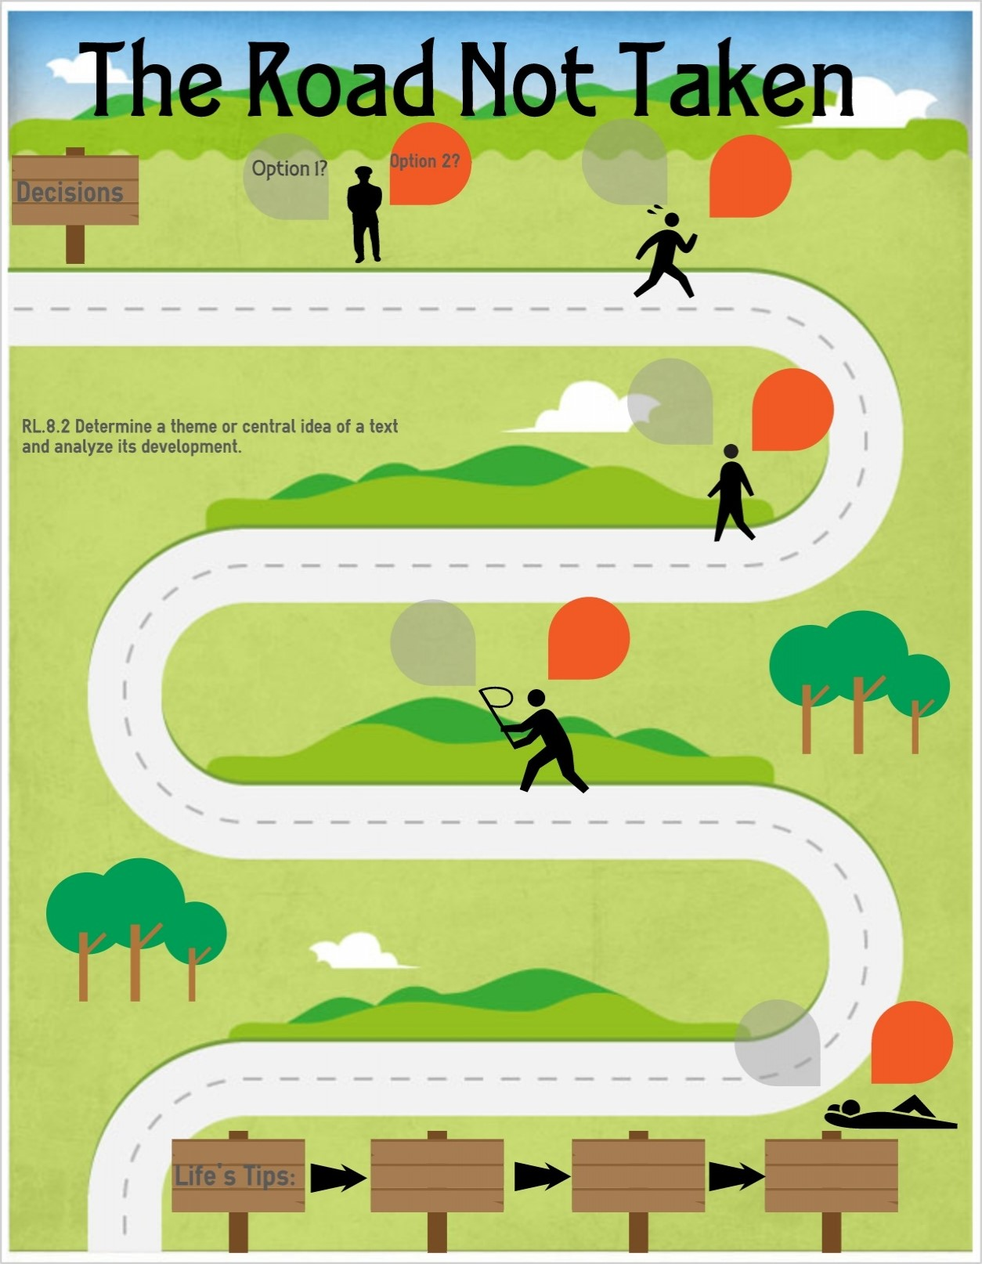
PSHE Themes:
(HeartSmart)
-Get HeartSmart

-Don’t forget to let love in!
-Too much selfie isn’t healthy!
-Don’t rub it in, rub it out
-Fake is a mistake

-‘No way through’ isn’t true
Families and people who care for me
Pupils should know…
-that families are important for children growing up because they give love, security and stability.
-the characteristics of healthy family life, commitment to each other, including in times of difficulty, protection and care for children and other family members, the importance of spending time together and sharing each other’s lives
-that stable, caring relationships, which may be of different types, are at the heart of happy families, and are important for children’s security as they grow up
-how to recognise if family relationships are making them feel unhappy or unsafe, and how to seek help or advice from others if needed
How environmental changes may have an impact on living things

Caring Friendships
Pupils should know…
-how important friendships are in making us feel happy and secure, and how people choose and make friends
- the characteristics of friendships, including mutual respect, truthfulness, trustworthiness, loyalty, kindness, generosity, trust, sharing interests and experiences and support with problems and difficulties
-the healthy friendships are positive and welcoming towards others, and do not make others feel lonely or excluded
-that most friendships have ups and downs, and that these can often be worked through so that the friendship is repaired or even strengthened, and that resorting to violence is never right
-how to recognise who to trust and who not to trust, how to judge when a friendship is making them feel unhappy or uncomfortable, managing conflict, how to manage these situations and how to seek help or advice from others if need

Respectful Relationships
Pupils should know…
-the importance of respecting others, even when they are very different from them (for example, physically, in character, personality or backgrounds), or make different choices or have different preferences or beliefs.
-practical steps they can take in a range of different contexts to improve or support respectful relationships
-the importance of self-respect and how this links to their own happiness
-that in school and in wider society they can expect to be treated with respect by others, and in turn they should show due respect to others, including those in authority
-about different types of bullying (including cyberbullying), the impact of bullying, responsibilities of bystanders (primary reporting bullying to an adult) and how to get help
Understand and respect differences and diversity
Understand and respect differences and diversity within religions

Online relationships
Pupils should know…
-that people sometimes behave differently online, including by pretending they are someone they are not
-how to critically consider their online friendships and sources of information including awareness of the risks associated with people they have never met
Email safety (people are who they say they are)
How we can communicate with others online? (zip it, block it, flag it)
Use technology safely, respectfully and responsibly; recognise acceptable /unacceptable behaviour; identify a range of ways to report concerns about content and contact
Being safe
Pupils should know…
-what sort of boundaries are appropriate in friendships with peers and others (including in a digital context)
-how to respond safely and appropriately to adults they may encounter (in all contexts, including online) whom they do not know
-how to recognise and report feelings of being unsafe or feeling bad about any adult
-how to ask for advice or help for themselves or others, and to keep trying until they are heard
-how to report concerns or abuse, and the vocabulary and confidence needed to do so
-where to get advice e.g. family, school and/or other sources
Be discerning in evaluation digital content

YEAR 5 – RSHE Road Map
Relationships Education

