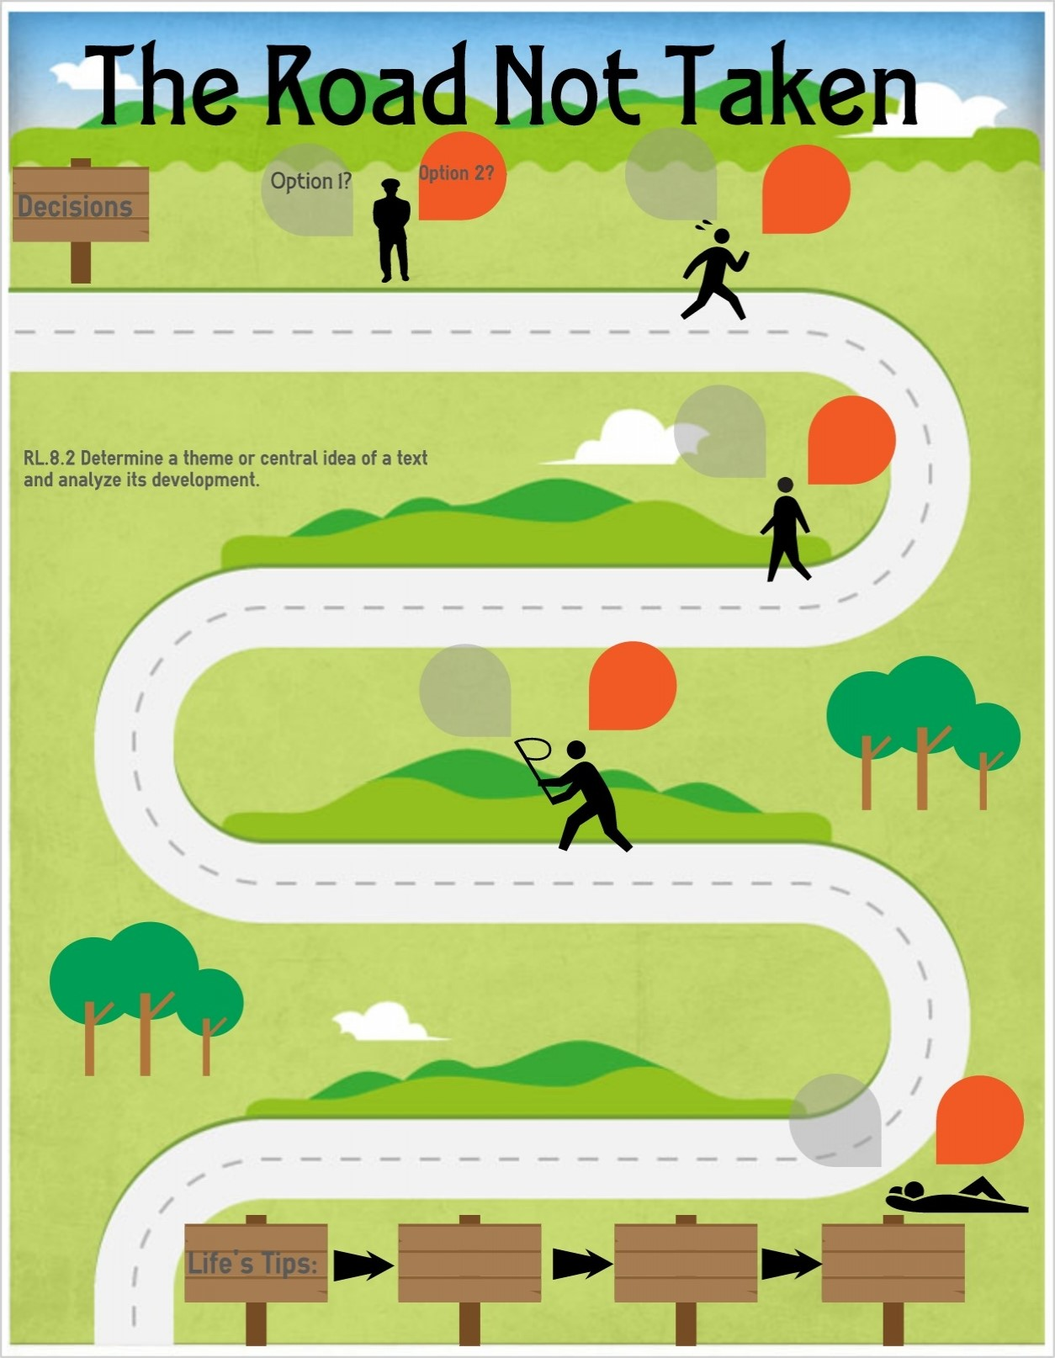
Mental Wellbeing
Pupils should know…
-that mental wellbeing is a normal part of daily life, in the same way as physical health
-that there is a normal range of emotions (e.g. happiness, sadness, fear, anger, surprise, nervousness) and scale of emotions that all humans experience in relation to different experiences and situations
-how to recognise and talk about their emotions, including having a varied vocabulary of words to use when talking about their own and others; feelings
-how to judge whether what they are feeling and how they are behaving is appropriate and proportionate
-simple self-care techniques, including the importance of rest, time spent with friends and family and the benefits of hobbies and interests
-that bullying (including cyberbullying) has a negative and often long lasting impact on mental wellbeing
Spending time being connected to creation to support wellbeing
Enterprise project – growing and selling vegetable produce from the school poly tunnel and vegetable beds – to understand the benefits of physical exercise, time outdoors, community participation, voluntary and service-based activity on mental wellbeing and happiness
Health and Prevention
Pupils should know…
-about the benefits of rationing time spent online, the risk of excessive time spent on electronic devices and the impact of positive and negative content online on their own and others’ mental and physical wellbeing
-how to consider the effect of their online actions on others and know how to recognise and display respectful behaviour online and the importance of keeping personal information private
-why social media, some computer games and online gaming, for example, are age restricted
-how to be a discerning consumer of information online including understanding that information, including that from search engines, is ranked, selected and targeted
Search safety (being aware of what results may come back and what to do including trusted persons)

Physical Health & Fitness
Pupils should know…
Can pace to run distance
Take part in vigorous physical activity for 30 minutes or more 3 times a week
Know the major muscle groups and how to ensure they are prepared effectivity for different activities
Healthy Eating
Pupils should know…
Recognise the impact of describe the effects of diet, exercise, drugs and lifestyle on the way bodies function
Pizza making – exploring different pizzas and bases and designing and creating their own pizza with a range of toppings
Enterprise project – growing and selling vegetable produce from the school poly tunnel and vegetable beds
Drugs, Alcohol and Tobacco
Pupils should know…
-the facts about legal and illegal harmful substances and associated risks, including smoking, alcohol use and drug-taking
Recognise the impact of describe the effects of diet, exercise, drugs and lifestyle on the way bodies function

Basic First Aid
Pupils should know…
St Johns Ambulance Lesson – Choking
St Johns Ambulance Lesson – Basic Life Support

Changing Adolescent Bodies
Pupils should know…
-key facts about puberty and the changing adolescent body, particularly from age 9 through to age 11, including physical and emotional changes
Coming of age ceremonies – Bar Mitzvah and Bat Mitzvah, the Sacred Thread ceremony, Confirmation etc…
Internet Safety and Harms
Pupils should know…
-about the benefits of rationing time spent online, the risk of excessive time spent on electronic devices and the impact of positive and negative content online on their own and others’ mental and physical wellbeing
-how to consider the effect of their online actions on others and know how to recognise and display respectful behaviour online and the importance of keeping personal information private
-why social media, some computer games and online gaming, for example, are age restricted
-how to be a discerning consumer of information online including understanding that information, including that from search engines, is ranked, selected and targeted
Search safety (being aware of what results may come back and what to do including trusted persons)
Email safety (people are who they say they are)

PSHE Themes:
(HeartSmart)
-Get HeartSmart

-Don’t forget to let love in!
-Too much selfie isn’t healthy!
-Don’t rub it in, rub it out
-Fake is a mistake

-‘No way through’ isn’t true
YEAR 6 – RSHE Road Map
Health Education

