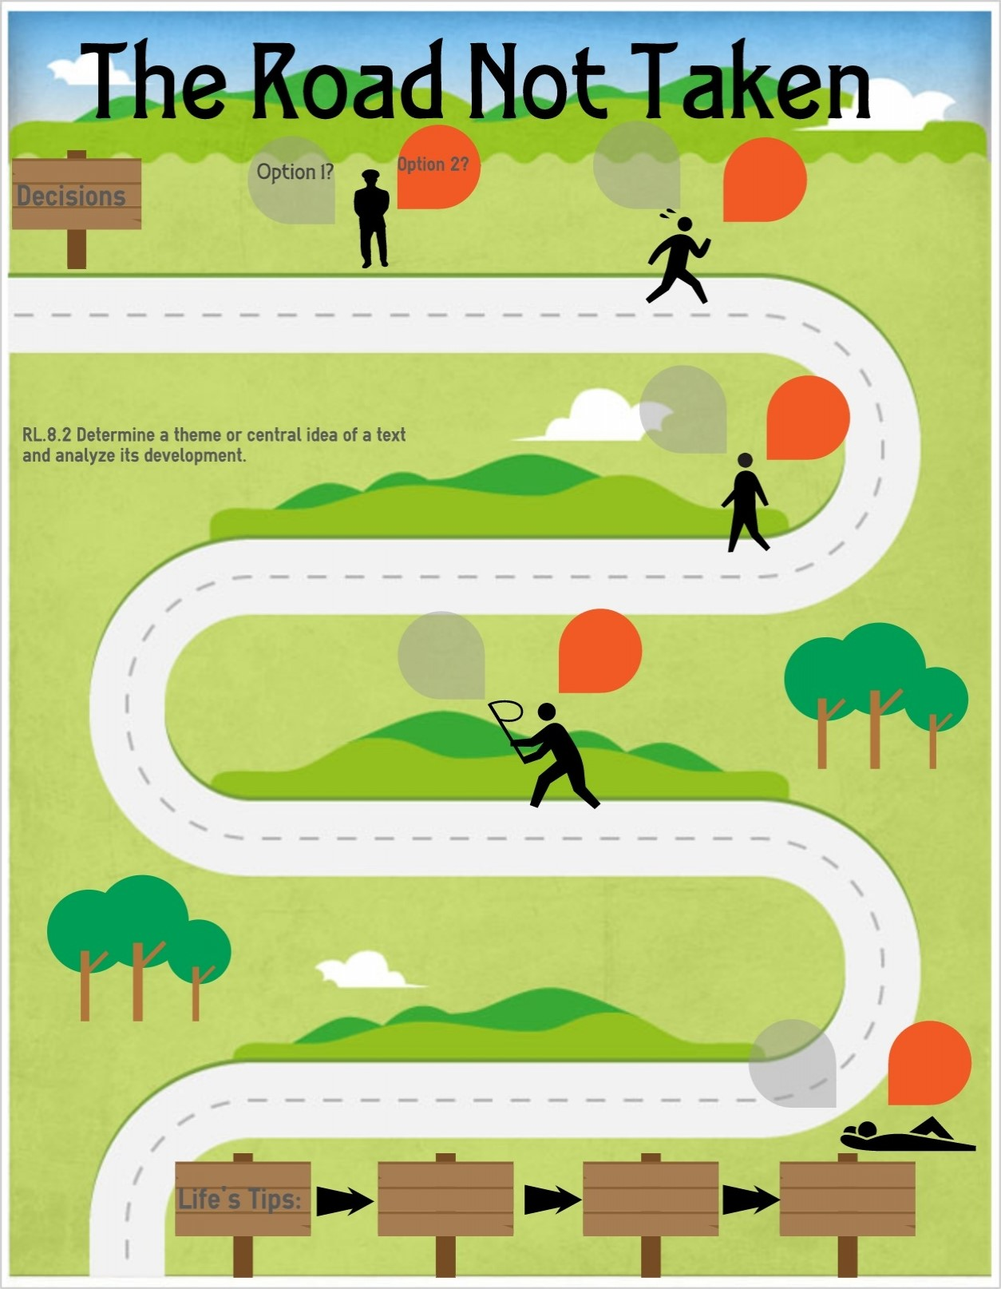
PSHE Themes:
(HeartSmart)
-Get HeartSmart

-Don’t forget to let love in!
-Too much selfie isn’t healthy!
-Don’t rub it in, rub it out
-Fake is a mistake

-‘No way through’ isn’t true
Being safe
Pupils should know…
-what sort of boundaries are appropriate in friendships with peers and others (including in a digital context)
-about the concept of privacy and the implications of it both for children and adults; including that it is not always right to keep secrets if they relate to being safe
-how to recognise and report feelings of being unsafe or feeling bad about any adult
Can ride a bike showing road proficiency and safely
Be discerning in evaluation digital content

Online relationships
Pupils should know…
-that people sometimes behave differently online, including by pretending they are someone they are not
Social media and Weiquette – case studies (how should you respond?)
Use technology safely, respectfully and responsibly; recognise acceptable /unacceptable behaviour; identify a range of ways to report concerns about content and contact
Respectful Relationships
Pupils should know…
-the importance of respecting others, even when they are very different from them (for example, physically, in character, personality or backgrounds), or make different choices or have different preferences or beliefs.
-practical steps they can take in a range of different contexts to improve or support respectful relationships
-the importance of self-respect and how this links to their own happiness
-that in school and in wider society they can expect to be treated with respect by others, and in turn they should show due respect to others, including those in authority
-about different types of bullying (including cyberbullying), the impact of bullying, responsibilities of bystanders (primary reporting bullying to an adult) and how to get help
Know what is expected in relation to conduct and etiquette in various scenarios or contexts
Can work independently to set up the lesson and transition between activities whilst challenging themselves and others in a supportive cooperative manner in various activities
Understand and respect differences and diversity
Responsibility of creation (including caring for each other)
Caring Friendships
Pupils should know…
-how important friendships are in making us feel happy and secure, and how people choose and make friends
-the characteristics of friendships, including mutual respect, truthfulness, trustworthiness, loyalty, kindness, generosity, trust, sharing interests and experiences and support with problems and difficulties
-the healthy friendships are positive and welcoming towards others, and do not make others feel lonely or excluded
-that most friendships have ups and downs, and that these can often be worked through so that the friendship is repaired or even strengthened, and that resorting to violence is never right
-how to recognise who to trust and who not to trust, how to judge when a friendship is making them feel unhappy or uncomfortable, managing conflict, how to manage these situations and how to seek help or advice from others if need
Design and complete your own orienteering course developing teamwork, resilience and cooperation
Know how to support others in improving their own performance
Caring for each other and the world – creation and science

Families and people who care for me
Pupils should know…
-that families are important for children growing up because they give love, security and stability.
-that others’ families, either in school or in the wider world, sometimes look different from their family, but they should respect those differences and know that other children’s families are also characterised by love and care
-that marriage represents a formal and legally recognised commitment of two people to each other which is intended to be lifelong
Describe how living things are classified into broad groups according to common observational characteristics and based on similarities and differences
Understanding that family rites of passage and beliefs are really important within different religions and are believed to help support the idea of families being important to give love, security and stability.
Understand how marriage is an important legal and religious commitment of two people who love each other
To respect how different religions have varying beliefs on families, roles and responsibilities and the bringing up children
How environmental changes may have an impact on living things

YEAR 6 – RSHE Road Map
Relationships Education

