Church in the Porch
Sunday 7th February –2nd Sunday before Lent

In the beginning…

Gospel of John
Chapter 1, verses 1-14

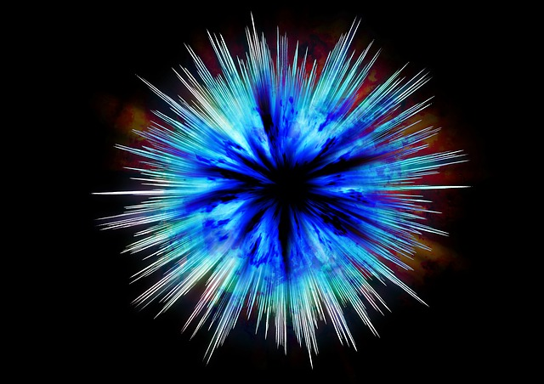

www.asn.church
Our reading from the Gospel this week…
In the beginning was the Word, and the Word was with God, and the Word was God. He was in the beginning with God. All things came into being through him, and without him not one thing came into being. What has come into being in him was life and the life was the light of all people. The light shines in the darkness, and the darkness did not overcome it.
There was a man sent from God, whose name was John. He came as a witness to testify to the light, so that all might believe through him. He himself was not the light, but he came to testify to the light. The true light, which enlightens everyone, was coming into the world.
He was in the world, and the world came into being through him; yet the world did not know him. He came to what was his own, and his own people did not accept him. But to all who received him, who believed in his name, he gave power to become children of God, who were born, not of blood or of the will of the flesh or of the will of man, but of God.
And the Word became flesh and lived among us, and we have seen his glory, the glory as of a father’s only son, full of grace and truth.

Something to think about…
Today’s Bible passage is a very famous bit of the Bible. It’s the beginning of the last of the four Gospels, the one written by John. It is read every year at Christmas time, and today we hear it again. It’s quite a mysterious passage though, and it can seem hard to understand. The best way to try to understand it is to read it little bit by little bit, and to think about what each sentence tells us.
The ‘Word’ is a special name for Jesus. So this Gospel tells us that Jesus was there at the very beginning of everything. Indeed he was there even before the beginning of everything with God, because he is God. Everything that was made was made through Jesus, because Jesus is the light of the world – and because Jesus gives life.
It’s difficult for us to think that Jesus was there at the very beginning of everything, and was also here on earth 2,000 years ago being born in Bethlehem, and is here through the power of the Holy Spirit in our hearts today. How is that possible?! But that, I guess, is why God is so amazing: he is so much more than we can ever imagine.
John tells us that when Jesus came into the world, many of his own people did not realise that he was God among us, ‘Emmanuel’. They did not realise that this was their Saviour, born as a little baby. But some people did know – these were Jesus’ first disciples. They saw the amazing things that Jesus did and they realised this was the person to help us to really know God and how much God loves us.
Over the next few weeks, we will be learning a little about what Jesus did in his life. We will hear stories of how Jesus wants people to see the love of God and to be a part of the kingdom promised for so many years. We will also hear how the people in his time on earth didn’t understand, how rulers were frightened by his amazing powers, and how they decided that he would have to die. It is a sad story sometimes, but when we get to the sad bits, we just need to remember something else that John tells us in the Gospel today: the Light came into the world, and the darkness could not overcome it!

Rev. Teena

Things to do…
Look at the sky
Tonight why not wrap up warm (perhaps take a sleeping bag and a deckchair and a cup of hot chocolate) and go and sit outside in the garden for a little while to just look at the universe that God created. Try to count the stars. Imagine how far away each one is. Imagine how old each one is. Imagine God creating all of this – and you!
Can you find these star constellations in the night sky?
Orion the hunter

Ursa Major – the Great Bear – the Plough

Make an infinity mobile
‘Infinity’ is a difficult word to explain. Basically it means ‘more than any number that you could ever think of’ – so whatever the biggest number is that you could imagine, infinity is that plus one. Or that plus many more.
When something is ‘finite’ it has an end. Infinity does not have an end. There is a symbol for infinity – just as there are symbols for our numbers. The symbol for infinity is like the symbol for a number eight, but on its side.
God is infinite. God has no end. Whatever we imagine anything to be, God is bigger than that. God is bigger than anything that we could possibly imagine.
Why not make the infinity mobile and hang it in your window? As it catches the light of the rays from the sun, think what it means for God to be bigger than any distance that you can even imagine – for example the distance from the Earth to the Sun, or the nearest star.
You will need:
Black paper (included in the resource pack)
String (included in the resource pack)
Tin foil (included in the resource pack)
Stickers and gems (included in the resource pack)
A dowel, bamboo cane (or a pencil if you don’t have these)
Sellotape and glue
Scissors
- Using the template on the next page, cut 2 infinity symbols out of the black paper.
- Cut 2 teardrop shapes out of tin foil. Glue these between the two infinity symbols.
- Attach 2 pieces of string to either end of the pencil/dowel and then to each side of the infinity shape so that it hangs level from the pencil/dowel.
- Attach another piece of string from the centre of the pencil/dowel and make a small loop so that you can hang your mobile.
- Cut more shapes (diamonds, teardrops) out of the tin foil and use any remaining string to hang these below the infinity shape.
- Hang your mobile in a sunny window where it will catch the light.

Prayer for this week…

O Infinite God, of life, goodness, and generous love,
I give my heart, my life, to you.
Help me to love all human life,
and do all the good things that you want me to do.
Make me a loving example of your generous love,
and a blessing to everyone I see.
May your goodness be fully in us,
and in all that we think, and say and do.
Amen

Colouring page…
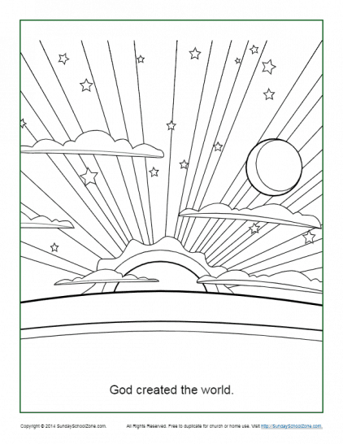

Services at All Saints Nettleham, and our church offering in the community

The church continues to keep the situation as regards the coronavirus under constant review. As soon as we deem it safe to return to worship in person in church we will do so. General worship at our Sunday service at 10am is likely to return before family worship at 4pm but you are warmly welcomed at both and we will ensure that there are resources for children available at the service at 10am.

Over the coming weeks, we will be continuing to supplement whatever services we are able to offer with resources in our churchyard, the church porch and in the stable. We will also continue to offer our 4-weekly service online. Please do help yourselves to any of the resources that are on offer, and keep your eye on our Facebook page and website for more information about what is happening.

We do hope to be able to return to church before Easter, and to be able to baptise children in the months afterwards. If you would like your children to be placed on the list to be baptised in your church, or to receive first communion at one of our AllSaints@4 Holy Communion services, please do contact Fr. Richard or Rev. Teena to discuss this.

Get in touch: teena@asn.church / www.asn.church
Office: admin@asn.church or phone 01522 931076
Find us on Facebook: All Saints Nettleham

