[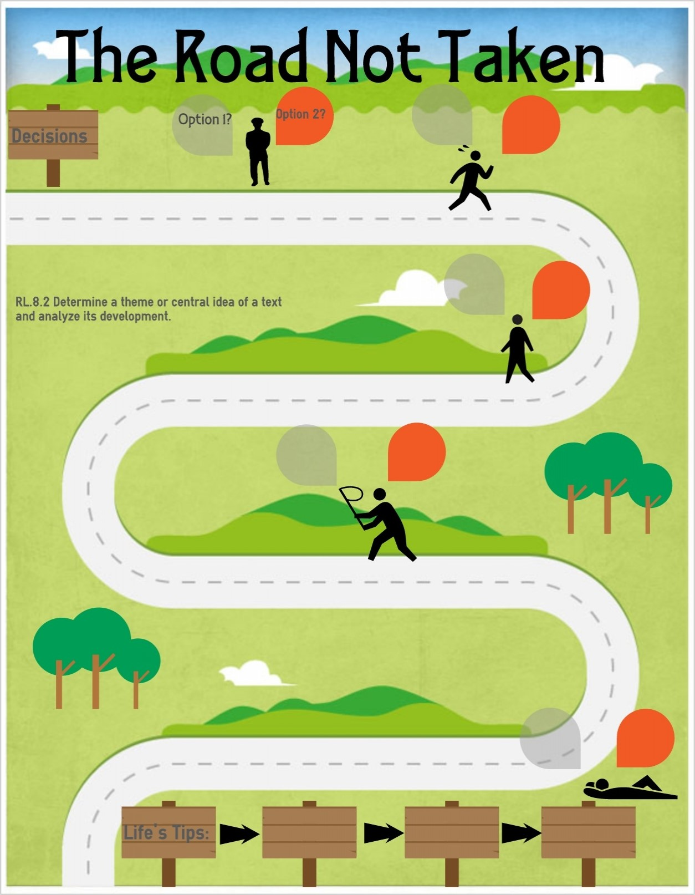](https://www.google.co.uk/url?sa=i&url=https%3A%2F%2Fwww.easel.ly%2Fblog%2Fspotlighting-the-reading-literature-standard-2%2Fimage3-2%2F&psig=AOvVaw3kz7SIqO8-5zpS1PMo6LEK&ust=1594810659830000&source=images&cd=vfe&ved=0CAIQjRxqFwoTCODYpIDLzOoCFQAAAAAdAAAAABAK)

Changing Adolescent Bodies

*Pupils should know…*

-key facts about puberty and the changing adolescent body, particularly from age 9 through to age 11, including physical and emotional changes

-about menstrual wellbeing including the key facts about the menstrual cycle

Describe and compare different reproductive processes and life cycles in animals

Describe the changes as humans develop to old age

Health and Prevention

*Pupils should know…*

-the importance of sufficient good quality sleep for good health and that a lock of good sleep can affect weight, mood and ability to learn

Understand how to prepare and recover from physical activity

Healthy Eating

*Pupils should know…*

To investigate spices that are used within Indian cooking. To prepare, cook and taste Indian meals – vegetarian and meat dishes as well as making a Indian fruit drink

(Optional extra – Fairtrade cooking and enterprise selling to raise money for TearFund) Understand the importance of Fairtrade on people around the world

Physical Health & Fitness

*Pupils should know…*

Can learn whilst moving for 40 minutes through vigorous physical activity without a break

Can physically challenge myself to improve

Internet Safety and Harms

*Pupils should know…*

-about the benefits of rationing time spent online, the risk of excessive time spent on electronic devices and the impact of positive and negative content online on their own and others’ mental and physical wellbeing

-how to consider the effect of their online actions on others and know how to recognise and display respectful behaviour online and the importance of keeping personal information private

-why social media, some computer games and online gaming, for example, are age restricted

-how to be a discerning consumer of information online including understanding that information, including that from search engines, is ranked, selected and targeted

Search safety (being aware of what results may come back and what to do including trusted persons)

Email safety (people are who they say they are)

Mental Wellbeing

*Pupils should know…*

-that mental wellbeing is a normal part of daily life, in the same way as physical health

-that there is a normal range of emotions (e.g. happiness, sadness, fear, anger, surprise, nervousness) and scale of emotions that all humans experience in relation to different experiences and situations

-how to recognise and talk about their emotions, including having a varied vocabulary of words to use when talking about their own and others; feelings

-how to judge whether what they are feeling and how they are behaving is appropriate and proportionate

-isolation and loneliness can affect children and that it is very important for children to discuss their feelings with an adult and seek support

-that bullying (including cyberbullying) has a negative and often long lasting impact on mental wellbeing

Can mentally challenge myself to improve

That across many religions (specifically we explore Islam, Christianity and Hinduism) community is very important to offer support and encouragement

That within Islam (Zakat), Hinduism (providing alms, offering hospitality) and Christianity (supporting charities) getting involved in service based activity is important to the outworking of their faith

Eucharist – being made right with God (to support the wellbeing of those people with a Christian faith)

Charity project – raising money for Wah Pre Say – to understand the benefits of community participation, voluntary and service-based activity on mental wellbeing and happiness

Basic First Aid

*Pupils should know…*

St Johns Ambulance Lesson – Bleeding

St Johns Ambulance Lesson – Head Injuries

St Johns Ambulance Lesson – Allergies

Drugs, Alcohol and Tobacco

*Pupils should know…*

-the facts about legal and illegal harmful substances and associated risks, including smoking, alcohol use and drug-taking

PSHE Themes:

(HeartSmart)

-Get HeartSmart

-Don’t forget to let love in!

-Too much selfie isn’t healthy!

-Don’t rub it in, rub it out

-Fake is a mistake

-‘No way through’ isn’t true

YEAR 5 – RSHE Road Map

Health Education