Church in the Porch
Sunday 3rd January – 2nd Sunday of Christmas

Happy Christmas!


Gospel of John

Chapter 1, verses 10-14

www.asn.church
Our reading from the Gospel this week…
‘The true light was in the world, and the world came into being through him; yet the world did not know him.
He came to what was his own, and his own people did not accept him.
But to all who received him, who believed in his name, he gave power to become children of God, who were born, not of blood or of the will of the flesh or of the will of man, but of God.
And the Word became flesh and lived among us, and we have seen his glory, the glory as of a father’s only son, full of grace and truth.’
The New Revised Standard Version

Things to think about…

Why on earth is Rev. Teena starting off this week with Happy Christmas??? If you think that Christmas is all done and dusted, then you are in for a surprise! Christmas Day is over, that is true enough. But Christians celebrate Christmas for a lot longer than just one day. Most people make it last at least the Twelve Days of Christmas (like in the song). Some people (including us at All Saints) go right through until the end of the Season of Christmas (on the first Sunday in February, known as Candlemas). Others continue even longer than that!

Can you guess why people would want to continue to celebrate Christmas for a long time? There are many reasons.

- We’ve waited so long - all through the year - for this wonderful news of the birth of Jesus, the light of the world. Who wouldn’t want to celebrate the saviour of the world for as long as possible?
- We haven’t quite finished the Christmas story – the wise men or three kings have not yet arrived at the stable (as you will see if you come to our nativity outside church before the 6th of January)
- In days gone by, having a big party in deepest darkest winter would have made the cold, dark days pass by more quickly, and helped bring forward the time when spring’s warmth would return
- In days gone by, people would have stocked up on food for the winter, and so it would have been a time of feasting whilst they had plenty. (Today though, we’ve probably already eaten all the chocolate…we certainly have in my house!)

So it’s still Christmas – how wonderful is that? But what does that mean, once the turkey and stuffing have been eaten and the presents all unwrapped?

Our reading from the Gospel this week tells us what Christmas is really about. It’s not just about the turkey, stuffing, presents and parties – great fun those these things are. It’s really all about Jesus being born into the world, more than 2000 years ago, as the light of the world.

At the time, most people didn’t realise that this little baby was anything special. A few did – there were some shepherds who were told about him by angels; there were some wise men who followed a star from the East to find him. But for most people, the birth of this little boy wasn’t an amazing event at all.

But as Christians we believe that when Jesus was born, something changed: we were all able to become children of God, and to know God in a special way, through knowing Jesus. So we know that the gift of that little baby boy changed the world for ever.

The gift of Jesus that first Christmas day showed us just how much God loves us and that his love will never end. That is truly amazing! Never mind one day, or twelve days - that’s got to be worth celebrating all year round! So – Happy Christmas!!

Rev. Teena
Things to do…
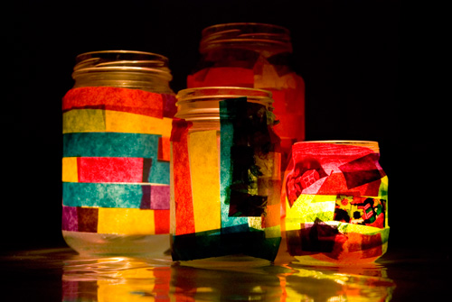
Jam-jar Lanterns (items included in the pack*)
Here’s a really lovely way to shine a light and think about the light of the world coming into the world. You will need:
- An old, clean jam jar
- Tissue paper or other see-through paper or plastic (Quality Street wrappers are brilliant!)*
- PVA glue or other glue that dries clear, such as modge-podge craft glue
- A paint brush
- A tealight (a battery operated one is best and safest)*
Paint your jam jar in glue – use as much as you like!
Tear up strips of your tissue paper/coloured plastic
and place them on the jar. Overlapping them will give
lots of different colours.
Add an extra coating of glue over the top to act as a varnish.
Pop your tealight inside the jamjar and let it glow!
Happy Hogmanay!
In Scotland they celebrate ‘Hogmanay’ at the beginning of a new year. Shortbread is a Scottish delicacy – so here’s a recipe for some shortbread stars, as we think about how the wise men are (just about now) following the light of that star to find the light of the world…

You will need:

INGREDIENTS EQUIPMENT
125g unsalted butter 6cm star shaped biscuit cutter
55g caster sugar, plus extra to sprinkle Baking sheet lined with baking paper
200g plain flour

METHOD
Step 1: Put the butter and sugar in the bowl of a food processor and blitz until well combined. Add the flour and pulse briefly until the mixture resembles breadcrumbs. Or work the butter gently into the flour by hand, then add sugar.
Step 2: Tip out the mixture onto a work surface and gently bring it together, then knead it into a dough. Once the dough is formed, wrap it in cling film and chill for 30 minutes. Preheat the oven to 200°C/180°C fan/400°F/Gas 6.
Step 3: Once the dough has chilled, lightly flour the work surface and roll out the dough until it is about 3mm thick (about the thickness of a £1 coin). Use the cutter to stamp out 16 biscuits, re-rolling the trimmings as necessary.
Step 4: Place the biscuits on the lined baking sheet and chill for another 5 minutes, then use a fork to prick a few lines of holes in the centre of each. Sprinkle the biscuits with a little caster sugar and bake for 10–12 minutes, or until lightly golden.
Step 5: Remove the biscuits from the oven and allow to cool on the baking sheet for 10 minutes. Then, transfer the biscuits to a wire rack to cool completely. The biscuits will keep in a sealed container for up to 1 week.

Prayers for this week…

Holy Jesus,

by being born one of us,

and lying humbly in a manger,

you show how much God loves the world.

Let the light of your love always shine in our hearts,

until we reach our home in heaven,

and see you on your throne of glory.

Amen.

May God, who has called us out of darkness

into his marvellous light,

bless us and fill us with peace.

Amen.

Lord Jesus,

You came to show us God’s love

That he would love us for ever and ever.

You came to give us God’s peace

That would give us comfort and rest.

You came to teach us how to live

So that we might build your kingdom here on earth.

May we follow you, day by day,

And love you as you love us.

Amen.

Colouring page…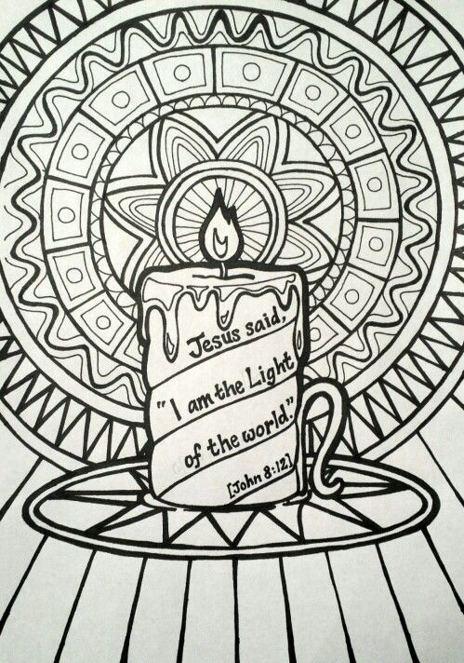
Parents’ page…
Further information on church activities and contact details for the ministry team are available at www.asn.church. We’re currently unable to hold our AllSaints@4 services in church. You can still join us for worship anytime: by booking to join one of our Sunday 10am services in church (one weekly service is continuing during Tier 4 restrictions) by emailing admin@asn.church; or watching on our Facebook page (search All Saints Nettleham). We will continue to put resources for children and families in the church porch on Sundays and family services on our website/Facebook page every fortnight whilst the Tier 4 restrictions are in place. As soon as we can safely gather, we will!

We would love to bring children forward for Baptism/Christening and first communion in 2021, hopefully around Easter time. We hope that this will be a time of real celebration – and that we will be able to gather in church in person by that time to see it all happen. If you would like your child to be baptised or to be admitted to holy communion, or would like further information then please feel free to contact Rev. Teena (teena@asn.church or ring/text 07735 398040) for a chat about it.

For mums…I had really hoped to be able to run a mums’ evening crafting worship – on the theme of ‘Bubbles, baubles and a babe’ – in the run up to Christmas. Sadly Covid put paid to that. I’d still like to explore the idea though – just perhaps with fewer baubles! If you would be interested in joining me and others to explore through craft what it means to be a Christian, following the story of Jesus’ mother Mary, then do get in touch. The idea would be to run 6 sessions, probably over Zoom initially, with all resources (and a small bottle of Prosecco!) provided each week in a craft bag (for a small charge to cover costs). Think Church in the Porch – but for grown-ups, with live demos, and bubbles! Do let me know if you’d be interested, what times would suit, and if there are enough people we will make it happen! Rev. Teena

