Church in the Porch
Sunday 17th January –2nd Sunday of Epiphany

Becoming disciples
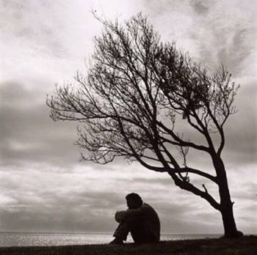

Gospel of John
Chapter 1, verses 43-49


www.asn.church

Our reading from the Gospel this week…
Jesus calls more disciples
The next day Jesus decided to go to Galilee. He found Philip and said to him, “Follow me.” Philip was from the town of Bethsaida, where Andrew and Peter lived. Philip found Nathanael and told him, “Remember that Moses wrote in the law about a man who was coming, and the prophets also wrote about him. We have found him. He is Jesus, the son of Joseph. He is from Nazareth.”
But Nathanael said to Philip, “Nazareth! Can anything good come from Nazareth?” Philip answered, “Come and see.”
Jesus saw Nathanael coming toward him. He said, “Here is truly a person of Israel. There is nothing false in him.” Nathanael asked, “How do you know me?” Jesus answered, “I saw you when you were under the fig tree. That was before Philip told you about me.”
Then Nathanael said to Jesus, “Teacher, you are the Son of God. You are the King of Israel.”

Something to think about…

Today’s story tells us about how Jesus called two of his disciples – Philip and Nathanael. These Bible stories tell us a lot about the kind of people that Jesus is looking for as his followers, and how it is that he asks you to be part of his team.

We don’t learn much about Philip, just that he was from Bethsaida, like Andrew and Simon, two of Jesus’ other disciples. He was probably just an ordinary chap like them – they were fishermen. Jesus found him, said ‘follow me’, and Philip did! But perhaps Philip might already have known Andrew and Simon and heard a bit about Jesus from them. Perhaps they had even told Jesus to go and look for Philip?

Philip doesn’t seem to need much encouragement to follow Jesus, does he? Jesus says ‘follow me’ and he does. And once he becomes one of Jesus’ followers, he goes to talk to his friend Nathanael about Jesus.

Nathanael is not very sure. He’s not that keen on Nazareth or people from Nazareth it seems. Perhaps you have heard people say things like this – ‘Oh, such-and-such a person won’t be nice…they come from this country or this city or this street’.

But Philip carries on encouraging him – he’s met Jesus and he knows how wonderful that is and he doesn’t want his friend to miss out. ‘Come and see!’ he says. Don’t just sit there, Nathanael, saying nasty things about someone that you’ve never even met. ‘Come and see!’

So Nathanael does. And Jesus, knowing perhaps that he was a bit of a grumpy, doubting sort of person throws in something amazing to convince him – ‘I saw you sitting under a fig tree, before Philip even came to see you.’ It’s Jesus’ way of saying that he was always right there waiting for Nathanael to come and say ‘yes’ to being a disciple.

So what does this story tell us about becoming a follower of Jesus?

It tells us that Jesus is always waiting for us to turn to him and follow him – but that he will ask us first! It tells us that Jesus accepts even those people who aren’t quite sure and need some convincing, and welcomes them with open arms. It also tells us that once we are disciples of Jesus, we have a job to do too – in telling others about him, and asking them to ‘come and see’.

Rev. Teena

Things to do…
Make a ‘what would Jesus do’ wristband…
This popular catchphrase comes from a book written in the 1800s, even though some people think it caught on 20 or so years ago. Wristbands with the letters WWJD on them became popular with Christians as a reminder to think always about how to follow Jesus in their daily lives and you can still buy them now. But they are easy to make too.
There are lots of different designs – you can see one to copy below, but come up with your own ideas and make it as colourful as you like.
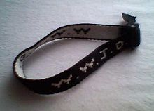
Enclosed in the resource pack this week are some webbing strap and a buckle for you to make your own at home. If you are downloading this content from the website you could use any webbing, tape or ribbon from home for the wristband, and simply tie off the ends.
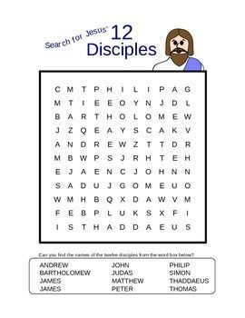and ME !
Prayers for this week…

The Lord’s prayer
This is the prayer that Jesus taught to his disciples when they asked him ‘Lord, teach us to pray’. It is a prayer that many Christians say every day, a prayer that all followers of Jesus know and love.
Our Father in heaven
hallowed be your name
your kingdom come, your will be done
on earth as in heaven.
Give us today our daily bread.
Forgive us our sins as we forgive those who sin against us.
Lead us not into temptation but deliver us from evil.
For the kingdom, the power and the glory are yours
now and forever
Amen.

A prayer for my family and friends
Loving God, bless my family, my friends and all in my heart today.
May they be safe and well and kept close to your peace and love.
Help me to know that you are with me
as I show love and care to others.
Amen.
Colouring pages…
Our first colouring page this week has a bit of a difference to it – can you find Philip?? (If you look carefully you might also see Nathanael!)

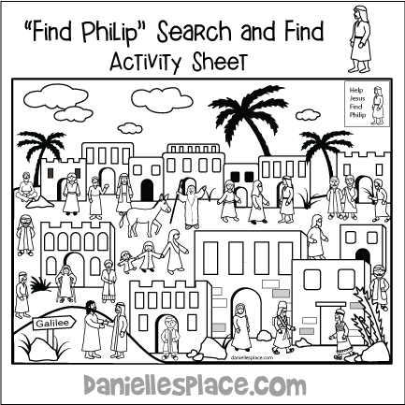
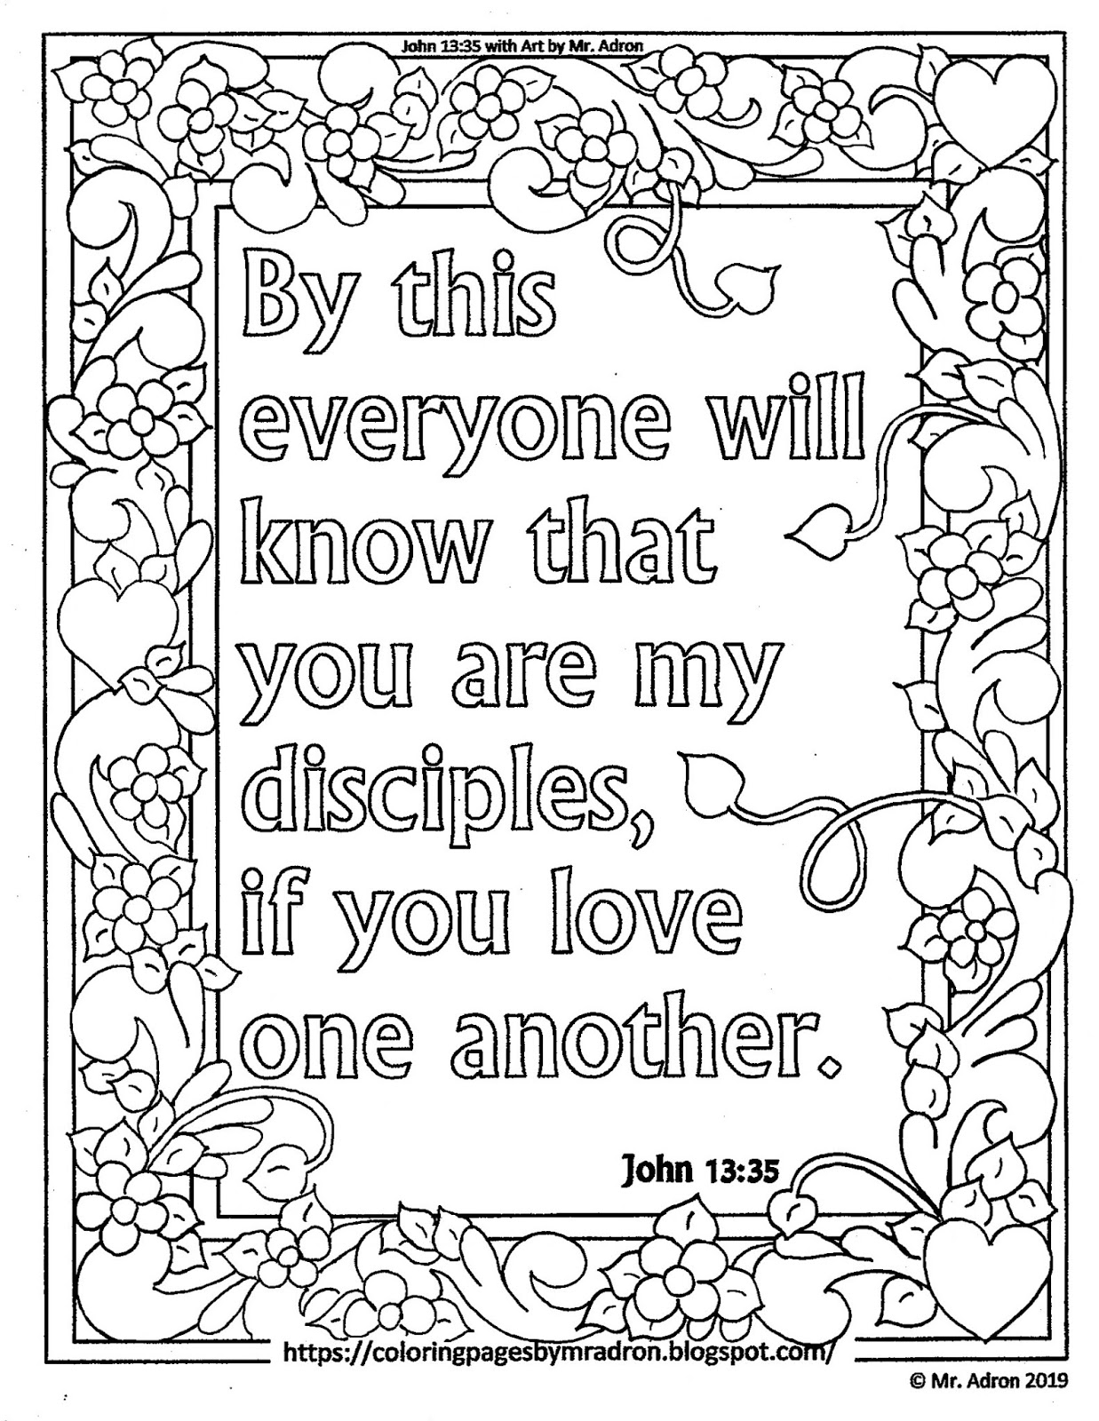

Did you know…
The sign of the fish


The early followers of Jesus were persecuted by Roman emperors. This meant that they had to meet in secret and not tell other people about their faith. So that they could recognise one another, they used secret signs and symbols. One special sign was ‘the sign of the fish’. Jesus called fishermen to be his first disciples and told them that they would be ‘fishing for people’. Today we recognise other Christians by the sign of the cross – but you may occasionally see this sign of the fish still today – usually on the back of a car!

Parents’ notes…
Further information on church activities and contact details for the ministry team are available at www.asn.church. We’re currently unable to hold our AllSaints@4 services in church. But you are still welcome to join us for worship online anytime watching on our Facebook page (search All Saints Nettleham) or on catch-up at www.asn.church .

We will continue to put resources for children and families in the church porch on Sundays and family worship resources on our website/Facebook page whilst the lockdown restrictions are in place. As soon as we can safely gather, we will!

