Church in the Porch
Sunday 24th January –3rd Sunday of Epiphany

It’s a miracle!
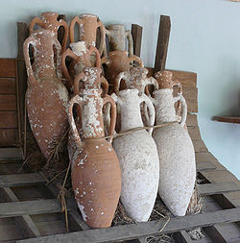

Gospel of John
Chapter 2, verses 1-11


www.asn.church

Our reading from the Gospel this week…
Two days later there was a wedding in the town of Cana in Galilee. Jesus’ mother was there. Jesus and his followers were also invited to the wedding.
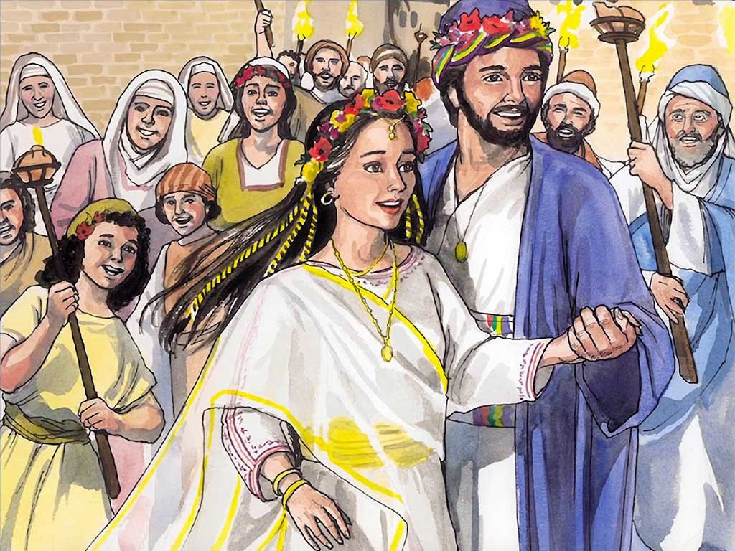
When all the wine was gone, Jesus’ mother said to him, “They have no more wine.” Jesus answered, “Dear woman, why come to me? My time has not yet come.”
His mother said to the servants, “Do whatever he tells you to do.”
In that place there were six stone water jars. The Jews used jars like these in their washing ceremony. Each jar held about 20 or 30 gallons. Jesus said to the servants, “Fill the jars with water.” So they filled the jars to the top. Then he said to them, “Now take some out and give it to the master of the feast.”
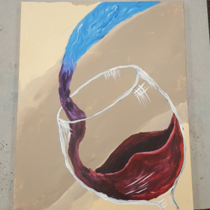
So the servants took the water to the master. When he tasted it, the water had become wine. He did not know where the wine came from. But the servants who brought the water knew. The master of the wedding called the bridegroom and said to him, “People always serve the best wine first. Later, after the guests have been drinking a lot, they serve the cheaper wine. But you have saved the best wine till now.”
So in Cana of Galilee, Jesus did his first miracle. There he showed his glory, and his followers believed in him.

Something to think about…
John tells us in this story that when Jesus performed miracles, people believed in him. We are asked to be his followers – but we don’t have any miracles to look at today. Or do we?
Some people do believe that miracles still happen. From time to time and very often after a lot of prayer God will answer us (although not always in the way that we were expecting him to!) Something might come out of the blue to sort out a problem, when we’d been wondering what we could do. Sometimes some help arrives from another person unexpectedly. I have seen a lot of this kind of miracle, and it is often because of Christian people reaching out to help.
This is one way that we can all play our part in being part of the miracle of God’s love, and building his kingdom here on earth. Jesus in this story showed people God’s love through a miracle of extraordinary generosity. We too can be part of the miracle of that overflowing love when we help one another.
In doing this, we will be doing what Mary said – doing what Jesus tells us. As followers of Jesus, we do try to live the way that he told us to, by loving one another as he loved us. But to the person who is on the receiving end of our help, it might just be a little miracle that has made their day.

Rev. Teena

Things to do…
Make a mini amphora
In Roman times, wine was transported around the empire in ships in special vases called amphora. There’s a picture of some amphora on the front cover. If you look at them you will notice something very strange for a vase – they have pointed ends! The strange shape was because they would be laid down side by side and tied together using rope passed through the handles. The shape meant that they stacked better, so more could be shipped at once.
Similar jugs were used for water, and these were very large – in the bible story this week there is an explanation that says that they would store between 20 and 30 gallons – that is between 90 and 135 litres – about half a bath-tubful!
So when Jesus changes the six jars of water into wine, he is giving the wedding couple a wonderful gift that will ensure that their celebrations are able to continue.
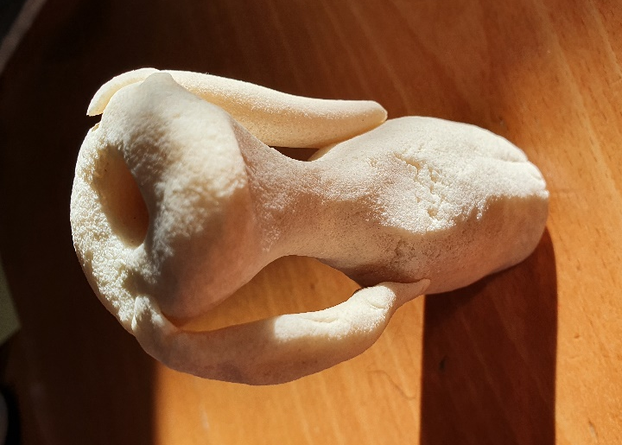
In this week’s resource pack there is some home-made craft dough which you can use to make your own amphora shape. If you want it to stand up, you will need to either find something to stand it in, or flatten the base. I made mine earlier and used a pencil to make a hole going down to the bottom. If you want to keep your amphora, you will need to bake the salt dough in your oven on its lowest setting for about 3 hours, which will make it hard. You can then paint it too. As you make your amphora, try and think of an idea for how you can take an ordinary situation and turn it into something special for someone else.
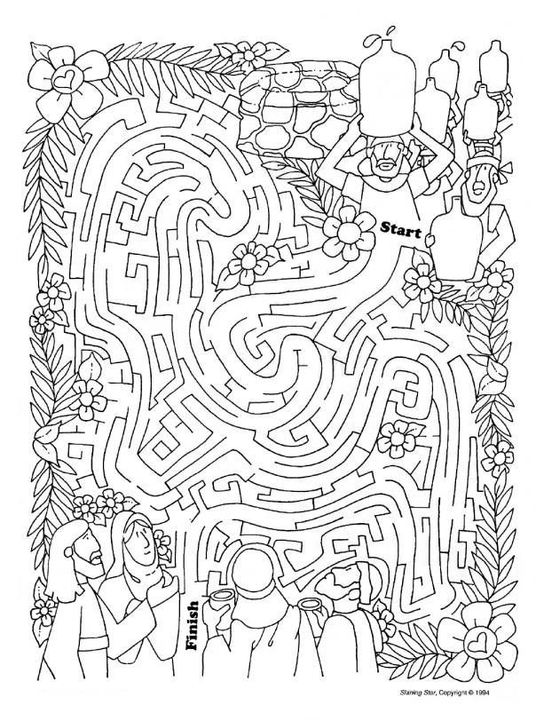


Help the water bearers find their way to Jesus so he can perform the miracle!
Prayers for this week…

Heavenly Father,
Thank you for the gift of your son, Jesus.
Thank you for your love and your generosity,
which overflows into my life.
Help me to share all the good things that you have given
so that other people may be blessed
by the ordinary miracle of your love.
In the name of Jesus our saviour, Amen.

A prayer for Christian unity
Lord Jesus, you prayed that we might all be one,
so we pray to you for the unity and togetherness of Christians,
and that you will help us to make this happen.
May the Holy Spirit help us
to see how much it hurts us when we do not love one another,
and to hope and pray for change.
Amen.

Colouring page…
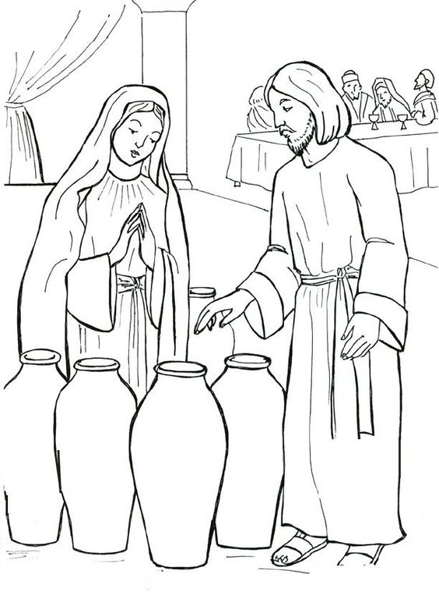
Did you know…
- Although the Bible tells us that the wedding took place at Cana, which was the town that Nathanael came from, (see last week’s CitP) – we no longer really know where Cana might be!
- One Biblical scholar has suggested that we might have mis-translated this bit of the Bible and that perhaps Jesus turned water into beer, rather than wine! Other people think that this is unlikely, as the word is used for ‘wine’ in other parts of the Bible.
- A Jewish wedding tradition is the breaking of a glass by the bridegroom. This is the signal for all the guests to shout ‘congratulations!’ to the newly married couple.
- Saint John has seven ‘signs’ in his telling of the Gospel story. The other six amazing miracles recorded in that gospel are:
  - Jesus healing the royal official's son in Capernaum
  - Jesus healing the paralysed man at Bethesda
  - Jesus feeding the 5000
  - Jesus walking on water
  - Jesus healing the man who was blind from birth
  - Jesus raising Lazarus from the dead

Parents’ notes…
Further information on church activities and contact details for the ministry team are available at www.asn.church. We’re currently unable to hold our AllSaints@4 services in church. But you are still welcome to join us for worship online anytime watching on our Facebook page (search All Saints Nettleham) or on catch-up at www.asn.church .
We will continue to put resources for children and families in the church porch on Sundays and family worship resources on our website/Facebook page whilst the lockdown restrictions are in place. As soon as we can safely gather, we will!

