Church in the Porch
Sunday 14th February – Sunday before Lent

Bumper Edition: Wow! , , and Love , light and peace!

Gospel of Mark
Chapter 9, verses 2-9


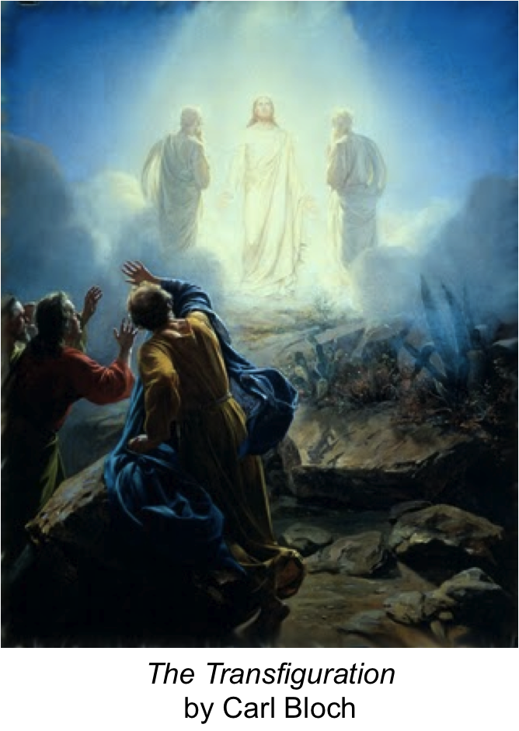

www.asn.church

Our reading from the Gospel this week…
Six days later Jesus took Peter, James, and John and went up on a high mountain. They were all alone there. While these followers watched, Jesus was changed. His clothes became shining white, whiter than any person could make them. Then two men appeared, talking with Jesus. The men were Moses and Elijah.
Peter said to Jesus, “Teacher, it is good that we are here. We will put three tents here—one for you, one for Moses, and one for Elijah.” Peter did not know what to say, because he and the others were so frightened.
Then a cloud came and covered them. A voice came from the cloud. The voice said, “This is my Son, and I love him. Obey him!” Then Peter, James, and John looked around, but they saw only Jesus there alone with them.
As Jesus and his followers were walking back down the mountain, he commanded them, “Don’t tell anyone about the things you saw on the mountain. Wait till the Son of Man rises from death. Then you may tell.”

Something to think about…
There is sooooooooooooo much to think about this week that I almost didn’t know where to begin – that’s what the list on the front page is all about. So, (thinking back to last week), we’ll begin in the beginning!
Wow! Our Gospel story today is all about the WOW factor that Jesus has. In this story, a miracle happens which is known as the ‘transfiguration of Jesus’. That’s a big long word, but it really just means that Jesus was changed. Jesus goes to a special place and is met by some very important people from the history of the Bible. He’s also spoken to by his father – God himself! Then something amazing happens – he begins to shine brightly like a light. It’s the power of God and God’s love shining through him! Peter and James who see it happening just don’t know what to make of it all – in some versions of the story they fall down on the floor with surprise!

I find that Jesus has this sort of effect on people even now – they just don’t know what to make of him. Many people when they first ask Jesus into their lives are overcome with surprise at how amazing and how transforming Jesus and God’s love can be!
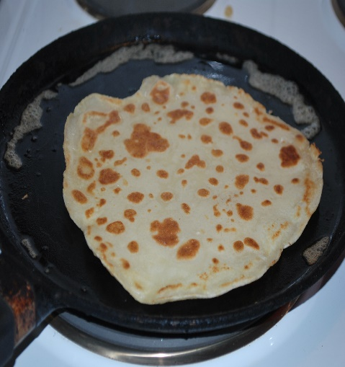
this is my attempt at a pancake pan! Tuesday 16th is pancake day, or, as we call it in church, Shrove Tuesday. It is a very ancient custom, connected to the season of Lent which begins on Ash Wednesday, the next day. During Lent, Christians think about things that they need to seek forgiveness for. They sometimes fast (don’t eat very much) and spend more time in prayer. Many ‘give something up for Lent’ - chocolate, for example. (Not me though – it’s too hard!) So Shrove Tuesday in the old days was when you had your last sweet, fatty food – and now we eat pancakes with lemon and sugar, or treacle, or chocolate spread! What’s your favourite?? There’s a recipe for pancakes in the booklet this week, and if you would like to join us on Zoom at 5 o’clock on pancake day for a service with a pancake-flipping competition, please do! Ask mum/dad/ grandma/ grandad to get in touch with us (details on the back).


The other thing that happens in church on Shrove Tuesday is that we burn the palm crosses from last year's Palm Sunday to make the ashes used during the services held on the very next day, which is called Ash Wednesday. If you come to an Ash Wednesday service, Fr. Richard or Rev. Judy will make the sign of the cross on your forehead with the ash! It’s a sign of your faith in Jesus, and some people leave it there all day. We’ve put an Ash Badge in the bag for you to wear.
Love , light and peace Lent is a time when as Christians we think about Jesus and what he means in our lives. In church we are thinking this Lent about Love light and peace, and our prayers in Church in the Porch for the next 6 weeks will come from our Lent course, so that you can join in too!
Rev. Teena

Things to do…
Jesus suncatcher

What you will need: (items marked * are included in the CitP bag)
- Some thick paper*

- String*
- Tracing paper or greaseproof paper*
- Decorative cord* (optional)
- Crayons or felt tip pens
- Scissors and glue

What you do:
Copy the picture on the next page onto the sheet of thick paper. Cut out the oval shape.
Cut an oval shape out of the tracing or greaseproof paper that is the same size as the other oval.


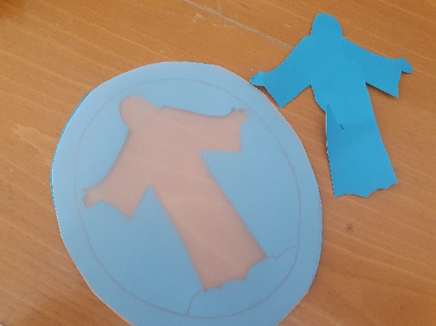
Next cut away the shape of Jesus from the middle of the sheet of thick paper (you may need to ask a grown-up to help you get started with this).
Glue the oval piece of tracing paper to the back of the oval paper.
On the front of the oval paper, colour around the cut-out shape of Jesus in white, yellow or gold, to look like the shining rays of the light. You might like to add glitter or shiny paper too.
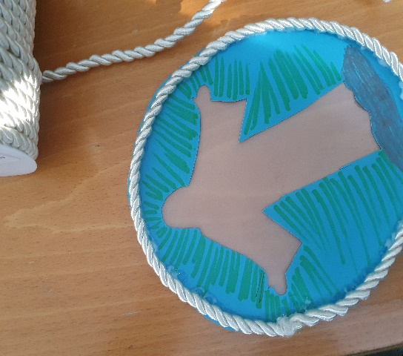
Glue the cord around the edges of the front of the oval shape, to make a nice frame to your picture. (If you don’t have cord, you could use wool, or just colour in the frame using a nice, bright colour.)
With the string, make a loop and Sellotape or glue it to the back of the picture. Hang your suncatcher in a sunny window, so that the light of the sun can shine through and make Jesus shine!

Make pancakes! You will need a grown-up helper for this activity!!!
You will need:
A frying pan (non-stick is best) 2 eggs
A few tablespoons of vegetable oil 110g plain flour
280ml milk 55g butter
The recipe makes about 8 pancakes. If you need more, just double the quantities! The filling and topping can be any type of jam, lemon and sugar, syrup, almost anything you fancy! (My favourite is tinned pears, flaked toasted almonds, and chocolate sauce).
 | Sift the flour into a mixing bowl and add the two eggs. Mix it all up with a whisk or a fork until the flour and eggs are well-mixed.  Add the milk slowly, a bit at a time, mixing it all together as you pour. Continue to mix until the batter is smooth with no lumps in it. Melt the butter in a pan and add 2 tablespoons of it to the batter and mix it in.

 | Now ask your grown up helper to help you. Put the pan on a medium heat and add a teaspoon of butter or a dash of oil to the pan. When it just begins to smoke, depending on the size of your pan, add 2 tablespoons (base 7in / 18cm pan) to 3 tablespoons (base 8in / 25cm pan) of the batter to the pan.  It's best to measure out the portions before pouring them in so that the mix can be poured in at the same time.

 | Immediately tip the pan from side to side to let the pancake batter cover all the base of the pan.  After 30 seconds or so the base of the pancake should be cooked. Lift up the side a bit with a palette knife or spatula to check that it's lightly browned. If not, cook for a few seconds more.

 | Flip the pancake over on to its other side and cook for 10 seconds.  Spread whatever topping you have chosen and wrap the pancake into a roll and serve hot.
Word hunt
How many words can you make out of the big word below? You get a point for each word, and 2 points if the word contains the shining letter ‘i’. We’ve started you off with two suggestions
transfiguration

train not
Garbled Gospel!!
Here’s another version of our Gospel story – but some words have got muddled up – can you help to sort it out?
The story of the artinsufangirto of Jesus
Six days later Jesus took three of his sidpciels - Peter, James, and John - and went up on a high miatnomu. They were all alone there. While these welorfols watched, Jesus was changed. His clothes became shining white, whiter than any person could make them. Then two men appeared, talking with Jesus. The men were Moses and Elijah.
Peter said to Jesus, “Rechate, it is good that we are here. We will put three tents here—one for you, one for Moses, and one for Elijah.” Peter did not know what to say, because he and the others were so derifteghn.
Then a cloud came and revoced them. A voice came from the cloud. The voice said, “This is my Son, and I love him. Obey him!” Then Peter, James, and John looked around, but they saw only Jesus there alone with them.
As Jesus and his followers were walking back down the mountain, he mocedmand them, “Don’t tell anyone about the things you saw on the mountain. Wait till the Son of Man rises from death. Then you may tell.”

artinsufangirto ……………………………. sidpciels …………………………….
miatnomu ……………………………. welorfols …………………………….
Rechate ……………………………. derifteghn …………………………….
revoced ……………………………. mocedmand …………………………….

Come and join our Pancake Party!


A family service with a pancake-flipping competition in the middle!

On Zoom at 5pm on ‘pancake day’ – Shrove Tuesday,
Tuesday 16th February.

Email Rev. Teena (teena@asn.church) or the parish office (Shirley on admin@asn.church) for a link for the Zoom.

Please prepare your pancakes ahead of the service and have a cold frying pan ready to flip!

Prayer for this week…
This week the Lent group at church is meeting to think about silence as Lent begins this Thursday. You can join in too! One really good way to think about silence during Lent (and to give something up for Lent that isn’t sweets, biscuits or chocolate!) is to challenge yourself that when you might be about to say anything horrible about anyone you just keep quiet - for the whole 40 days of Lent – so all the way until Easter. It is a lot harder than you might think. But it does mean that you really do deserve all the Easter eggs when they arrive!
Lent isn’t just about giving things up. It’s also about thinking about God and how much he loves us and we love him. It’s about thinking how we can be better followers of Jesus and make him the shining light in our lives. It’s good in Lent to spend some time every day in the quiet thinking about things like this. Why not light the tealight from your CitP bag and try and find some quiet time with God? Here’s your church’s prayer for this week whilst we all do just that:

Dear God,

Speak gently into our silence.
When the loud outer noises of our surroundings and the loud inner noises of our fears keep pulling us away from you, help us to trust that you are still there even when we are unable to hear you.
Let your loving voice be our guide.
Amen.

Colouring page…
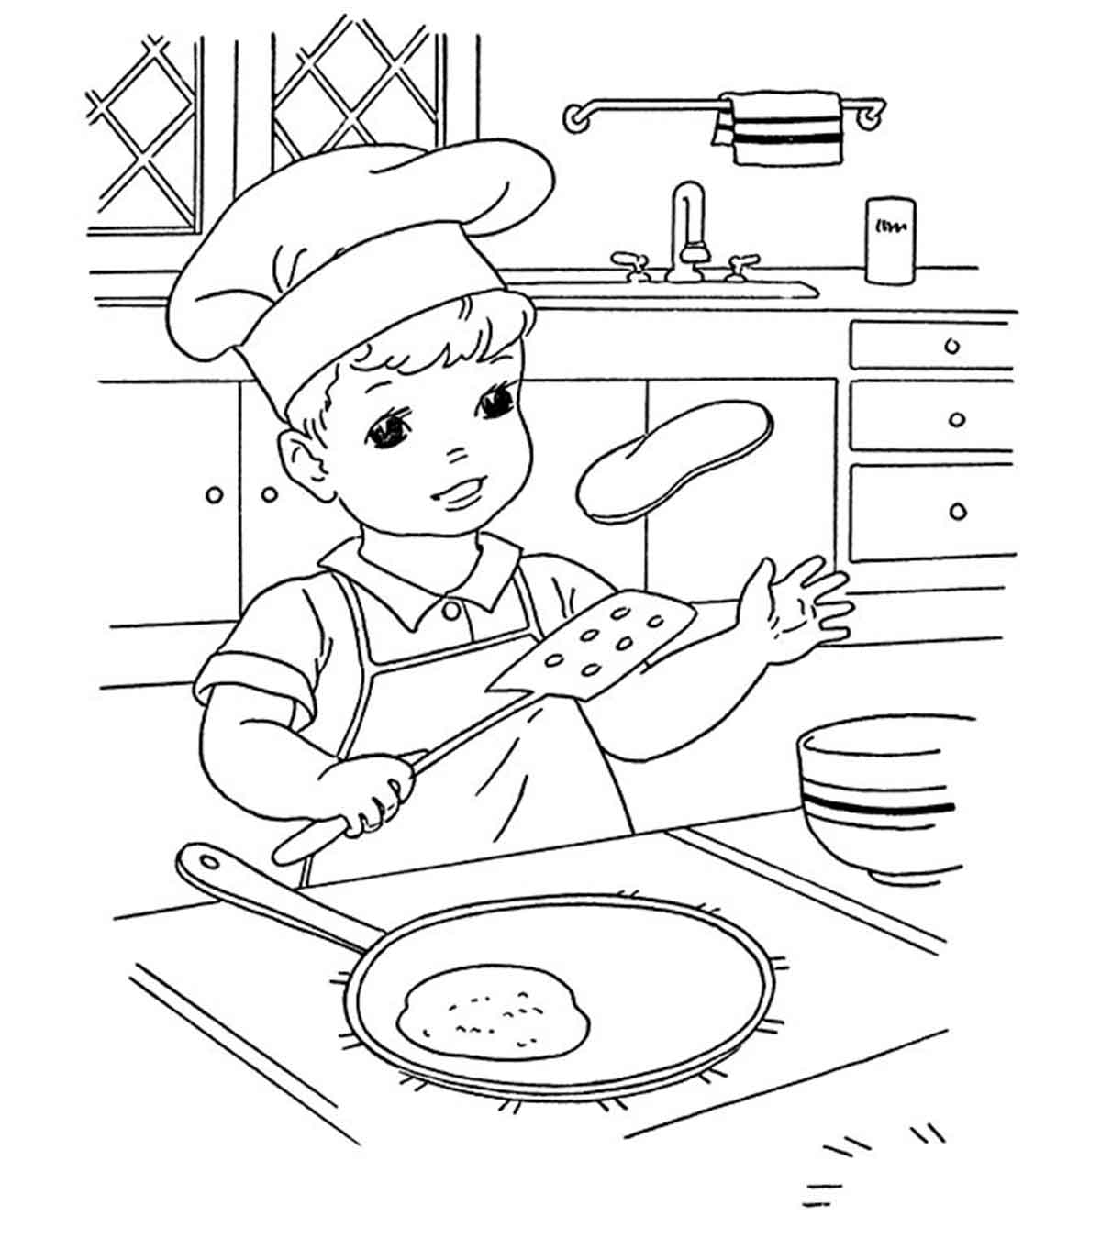

Services and other offerings from All Saints, Nettleham

Following a recent review, we are now restarting our general worship on Sunday at 10am. Because we are keeping numbers low, places are very limited (booking is required - admin@asn.church or ring number below). Families and children are always welcome to book into this service – or to join us on our Facebook live feed.

Over the coming weeks, we will continue to supplement our weekly services with resources in our churchyard, the church porch and in the stable. Please do help yourselves to any of the resources that are on offer. Do also keep your eye on our Facebook page and website for more information about what is happening. Our next online services for families are:
Shrove Tuesday pancake party – 5pm on Zoom (email for link)
Sun 28th February – AllSaintsOnline@4 pic’n’mix online worship

We hope to be able to return to church with a family AllSaints@4 service before Easter. We’d also love to be baptising children (and adults!) in the months afterwards. If you would like your children to be placed on the list to be baptised in your church, or to receive first communion at one of our AllSaints@4 Holy Communion services, please do contact Fr. Richard or Rev. Teena to discuss this.

Get in touch: teena@asn.church / www.asn.church
Office: admin@asn.church or phone 01522 931076
Find us on Facebook: All Saints Nettleham

