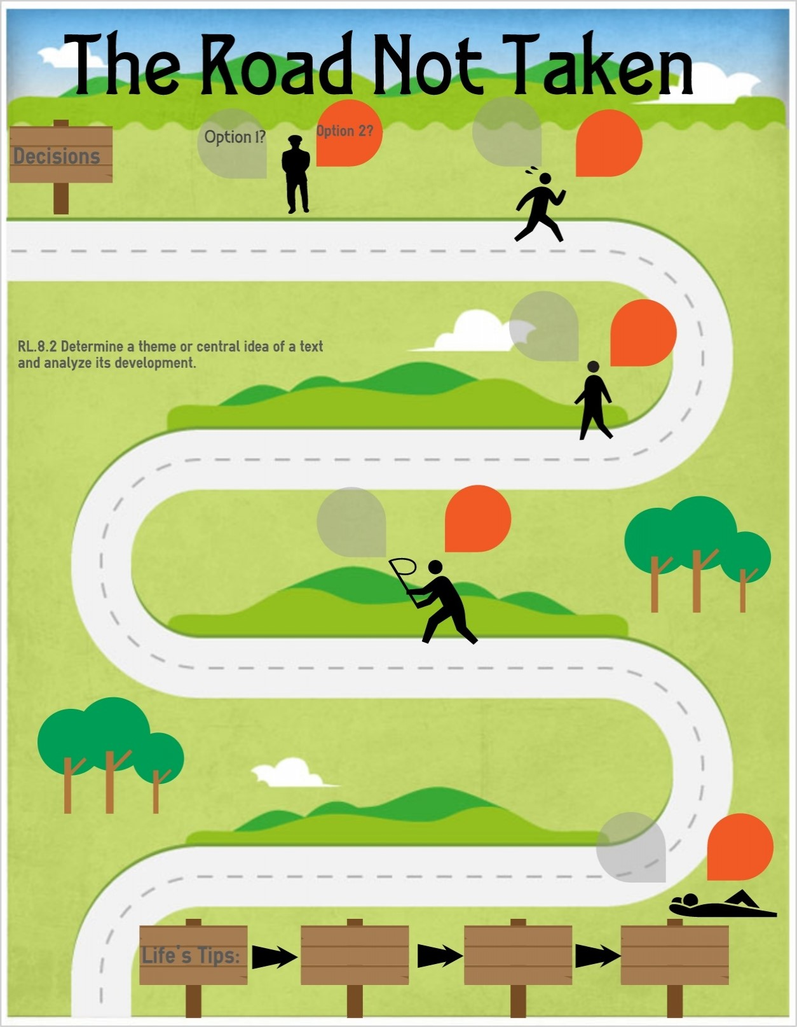
Basic First Aid
Pupils should know…
Perform safe self-rescue in different water-based situations
St Johns Ambulance Lesson – Asthma
St Johns Ambulance Lesson - Burns and Scalds

Changing Adolescent Bodies
Pupils should know…
-key facts about puberty and the changing adolescent body, particularly from age 9 through to age 11, including physical and emotional changes
Health and Prevention
Pupils should know…
-about personal hygiene and germs including bacteria, viruses, how they are spread and treated, and the importance of handwashing
How environmental changes may have an impact on living things
Identify the different types of teeth in humans and their simple functions and how we can maintain healthy teeth
Know how to ensure safety from sun burn and dehydration
Perform safe self-rescue in different water-based situations
Internet Safety and Harms
Pupils should know…
-that for most people the internet is an integral part of life and has many benefits
-about the benefits of rationing time spent online, the risk of excessive time spent on electronic devices and the impact of positive and negative content online on their own and others’ mental and physical wellbeing
-that the internet can also be a negative place where online abuse, trolling, bullying and harassment can take place, which can have a negative impact on mental health
-where and how to report concerns and get support with issues online
Search safety (being aware of what results may come back and what to do including trusted persons)
Password safety – why is it important?
Drugs, Alcohol and Tobacco
Pupils should know…
-the facts about legal and illegal harmful substances and associated risks, including smoking, alcohol use and drug-taking
Healthy Eating
Pupils should know…
Design and make apple crumble – collecting apples from the school grounds. Understanding the elements of nutrition that go into making the crumble – what aspects of a balanced diet are included in this recipe
Physical Health & Fitness
Pupils should know…
Can continuously run for over 12 minutes
Swim competently and proficiently over a distance of at least 25 metres in a recognised stroke on front
Use a range of strokes effectively (for example, front crawl, backstroke and breaststroke)
Pilgrimage in different faiths

Mental Wellbeing
Pupils should know…
-that mental wellbeing is a normal part of daily life, in the same way as physical health
-that there is a normal range of emotions (e.g. happiness, sadness, fear, anger, surprise, nervousness) and scale of emotions that all humans experience in relation to different experiences and situations
-how to recognise and talk about their emotions, including having a varied vocabulary of words to use when talking about their own and others; feelings
-how to judge whether what they are feeling and how they are behaving is appropriate and proportionate
-the benefits of physical exercise, time outdoors, community participation, voluntary and service-based activity on mental wellbeing and happiness
-that bullying (including cyberbullying) has a negative and often long lasting impact on mental wellbeing
-where and how to seek support (including recognising the triggers for seeking support), including whom in school they should speck to if they are worried about their own or someone else’s mental wellbeing or ability to control their emotions (including issues arising online)
-it is common for people to experience mental ill health. For many people who do, the problems can be resolved if they right support is made available, especially if accessed early enough
Know when to ‘move on’ in an activity and know what to change to challenge themselves but make sure the activity is still inclusive
Importance of community in different faiths
Pilgrimage – time to connect with God/spiritual experience (supports wellbeing)
PSHE Themes:
(HeartSmart)
-Get HeartSmart

-Don’t forget to let love in!
-Too much selfie isn’t healthy!
-Don’t rub it in, rub it out
-Fake is a mistake

-‘No way through’ isn’t true
YEAR 4 – RSHE Road Map
Health Education

