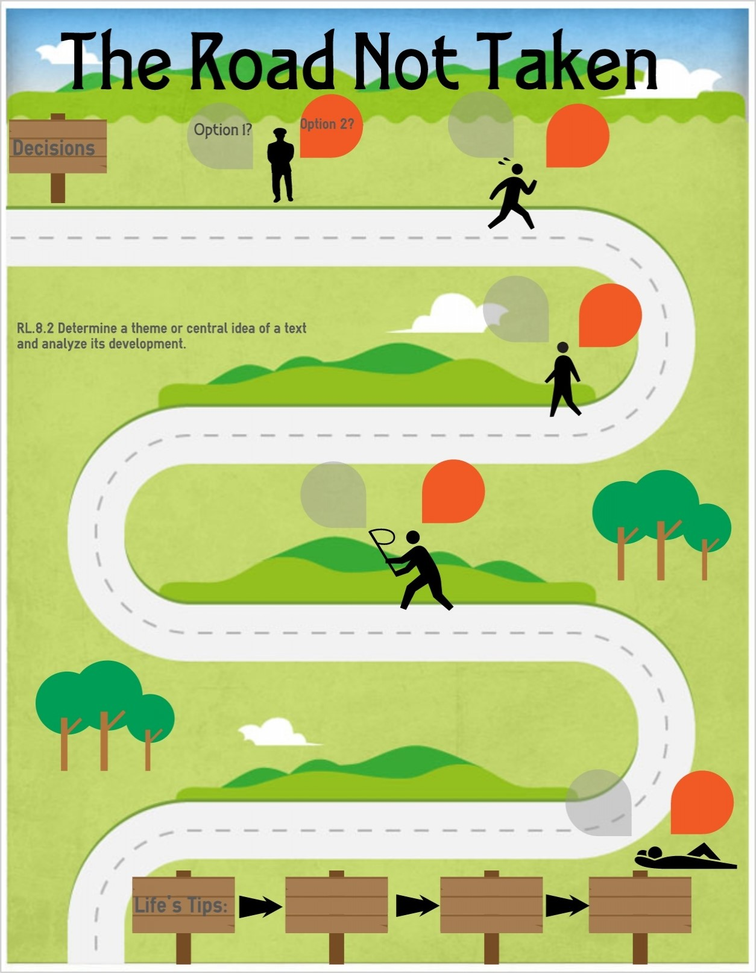
PSHE Themes:
(HeartSmart)
-Get HeartSmart

-Don’t forget to let love in!
-Too much selfie isn’t healthy!
-Don’t rub it in, rub it out
-Fake is a mistake

-‘No way through’ isn’t true
Being safe
Pupils should know…
-what sort of boundaries are appropriate in friendships with peers and others (including in a digital context)
-how to recognise and report feelings of being unsafe or feeling bad about any adult
-where to get advice e.g. family, school and/or other sources
Perform safe self-rescue in different water-based situations
Be discerning in evaluation digital content

Online relationships
Pupils should know…
Use technology safely, respectfully and responsibly; recognise acceptable /unacceptable behaviour; identify a range of ways to report concerns about content and contact

Respectful Relationships
Pupils should know…
-the importance of respecting others, even when they are very different from them (for example, physically, in character, personality or backgrounds), or make different choices or have different preferences or beliefs.
-practical steps they can take in a range of different contexts to improve or support respectful relationships
-the conventions of courtesy and manners
-the importance of self-respect and how this links to their own happiness
-that in school and in wider society they can expect to be treated with respect by others, and in turn they should show due respect to others, including those in authority
-about different types of bullying (including cyberbullying), the impact of bullying, responsibilities of bystanders (primary reporting bullying to an adult) and how to get help
-the importance of permission-seeking and giving in relationships with friends, peers and adults
Know when to ‘move on’ in an activity and know what to change to challenge themselves but make sure the activity is still inclusive
Understand and respect differences and diversity
Responsibility of creation (including caring for each other)

Caring Friendships
Pupils should know…
-how important friendships are in making us feel happy and secure, and how people choose and make friends
- the characteristics of friendships, including mutual respect, truthfulness, trustworthiness, loyalty, kindness, generosity, trust, sharing interests and experiences and support with problems and difficulties
-the healthy friendships are positive and welcoming towards others, and do not make others feel lonely or excluded
-that most friendships have ups and downs, and that these can often be worked through so that the friendship is repaired or even strengthened, and that resorting to violence is never right
-how to recognise who to trust and who not to trust, how to judge when a friendship is making them feel unhappy or uncomfortable, managing conflict, how to manage these situations and how to seek help or advice from others if need

Families and people who care for me
Pupils should know…
-that families are important for children growing up because they give love, security and stability.
-the characteristics of healthy family life, commitment to each other, including in times of difficulty, protection and care for children and other family members, the importance of spending time together and sharing each other’s lives
-that others’ families, either in school or in the wider world, sometimes look different from their family, but they should respect those differences and know that other children’s families are also characterised by love and care
that stable, caring relationships, which may be of different types, are at the heart of happy families, and are important for children’s security as they grow up
How environmental changes may have an impact on living things

YEAR 4 – RSHE Road Map
Relationships Education

