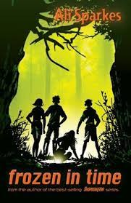
Bookworm Team

Book Title: Frozen in time
Author: Ali Sparks
Illustrator: N/A

What is this book about?
Two children called Freddy and Polly, get put into cryonic suspension having their hearts frozen until their father wakes them up again, the think it will be only for hour or so but is it…
2 children called Ben and Rachel live in the 21st century, when they find two frozen figures a boy and a girl. Spooky you may think but when Rachel accidentally presses a button something mysterious happen…

Who are the main characters?
Freddy, Polly, Ben, and Rachel.
What is the book about?
That it is spooky and mysterious and that two frozen figures will have to adapt to the 21st century.
This book was rated 4 stars

This book was read by Bethan. Sherriff
This book review was written by Bethan. Sherriff

