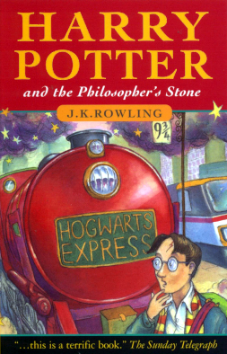
The Book Worms
Harry Potter and the philosophers Stone
Author J.K. Rowling
Illustrator Thomas Taylor
What’s this book about:
An eleven-year-old boy who’s a wizard goes to Hogwats and has to face the name we do not speak of.
Who are the main characters?
Harry Potter, Hermione, Ron, Hagrid and Voldemort.
What did you like about this book?
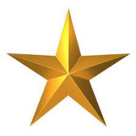
It’s so magical and mysterious. I think anyone who likes magic would like it.
Rating: 4 stars
This book was read by:
Ethan Richards
This Review was typed by:
Thomas Kidger

