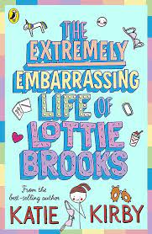
Bookworm Team
Book Title: Lottie Brooks
Author: Katy Kirby
Illustrator: Katy Kirby

What is this book about?
Her diary and weird things go along. There are multiple books different Series. It shows real-life problems in a series of books.
Who are the main characters?
Lottie Brooks, Jess, Molly (her friends)
Amber and Poppy, her hamsters. Brother, Toby, her mum and dad.
What did you like about this book?
How funny it is and how it explains solutions to problems in real life.

5 stars

This book was read by: Polly Pullen
This review was by: Bethan Sherriff

