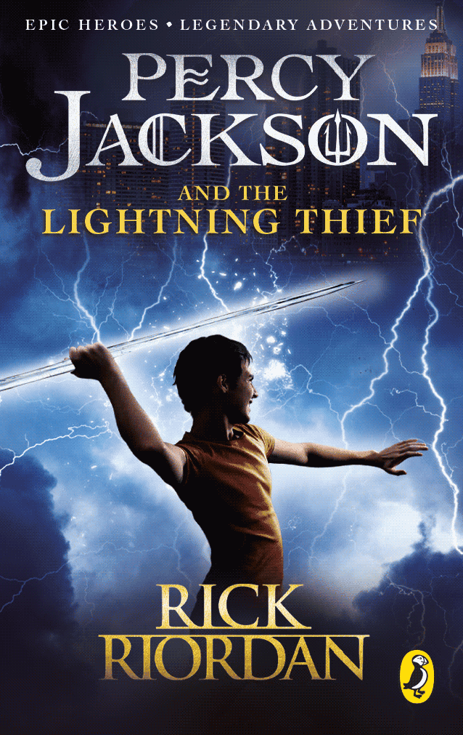
The book worm team

Book Title: Percy Jackson the Lightning thief.
Author: Ricky Riordan
Illustrator: N/A

What is this book about?
A boy called Percy, who is half blood of the gods. And Zeus thought Percy stole his lightning bolt.

Who are the main characters?
Percy, Zeus, Chiron, Annabeth.

What did you like about this book?
It’s all of a sudden. Helps learn about more Greek gods and myths.

Rating: 5 stars.

This book was read by: Malakai C
This Review was written by: Daisy

