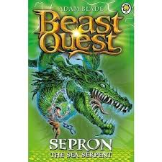
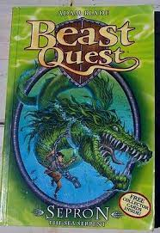
Book worms team
Tittle: sepron the sea serpent
Author: adam blade
Illustrator: adam blade
What is the book about:
It is about tom who continued his journey after finding a chain tide to a rock. Tom dives deep into the ocean to free sepron with his sword.
Who are the main characters:
Tom, Elena, Storm, Silver, sepron.
What did you like about this book:
How tom keeps diving into the ocean again and again after finally reaching sepron , he dropped the enchanted key that opened ferno , only to try again with his sword.


Rating: 5 stars
This book was read by: Samarth
This review was written by: Mia

