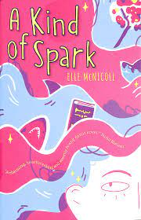
Book Worm Team

Book Title: A Kind Of Spark
Author: Elle McNicoll
Illustrator: Kay Wilson

What is this book about:
A girl called Addie who is autistic, and people do not understand her. She is learning to like herself and be more proud.
Who are the main characters:
Addie, Keedie, Nina.
What did you like about this book?
Helps to understand autism, really good and entertaining. Interesting and really makes you think.

This book was read by Mrs Salt
This review was written by Bethan Sherriff

This review was rated 4 stars out of 5 stars

