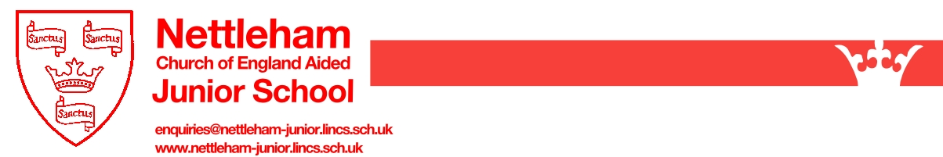
Nettleham CofE (VA) Junior School – The School Day

8.45 – 8.55 Children arrive at school
8.55 Registration – school begins
9.05 Lessons
10.15 Break
10.30 Lessons
12.15 Lunch
13.15 Assembly/Act of Worship
13:35 Lessons
15.30 End of School Day

School Uniform

The school has the following guidelines for uniform:

- Red sweatshirt or cardigan with embroidered school crest;

- White polo shirt with school crest (these were introduced as they can be worn under sweatshirts in winter and on cooler days but provide a cool, practical and smart option without a sweatshirt on warm summer days);

- White shirts or blouses are an alternative to a polo shirt;

- Grey trousers or skirt (girls are welcome to wear tailored grey trousers);

- Black shoes (girls should not wear shoes with high heels as these are dangerous in the playground);

- Dresses in red/white or green/white are acceptable alternative wear for girls in summer;

- Jewellery should not be worn to school (the only exceptions would be a plain wristwatch and small stud earrings if strictly necessary).

Clothing for PE: (please ensure all clothing and shoes are marked with the child's name)

Red School T Shirt
Black Shorts
School Sweat Shirt
Black Jogging Bottoms
White sports socks
Trainers
Plimsolls (optional for summer wear on the playground, or in the hall in the case of verrucas)

A sweatshirt and jogging bottoms are essential for PE outside on colder days. Girls may choose to wear a red or black leotard for indoor PE.

