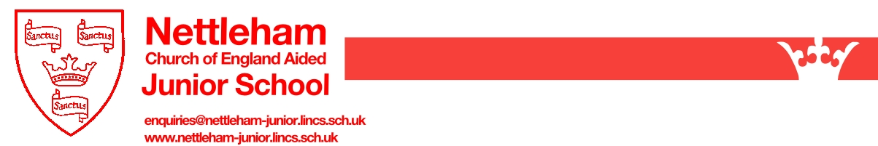

Photography & Film Permission Form – Nettleham CE Junior School

This information may be computerised and used for administration purposes. All personal information which is computerised has to be registered and may be used and disclosed only as described in the Data Protection Act 1998 and GDPR 2018 compliant.

This form explains the reasons why and how Nettleham Church of England Aided Junior School may use images and recordings of your child. Please read the form carefully and complete your agreement as appropriate.

Why do we need your consent?
To ensure we meet the requirements of GDPR we need to obtain your consent to take and use photographs/film. On admission in Year 3 we request the consent of parents to use images and recordings of their child for a variety of different purposes. Without your consent, the school will not use image and videos of your child. Similarly, if there are only certain conditions under which you would like images and films of your child to be used the school will abide by the conditions you outline in this form.

Why do we use images and recordings of your child?
We use images and film of pupils as part of school displays to celebrate school life and pupils’ achievements, to promote the school on social media and on the school’s website; and occasionally for other publicity purposes in printed publications, such as newspapers.
Where the school uses images of individual pupils the names of the children will not be disclosed.

Who else may use images and recordings of your child?
Occasionally the school is visited by local media and press who may take images/film of school events. Pupils will appear in these images and film and these may be published in local or national newspapers or on approved websites.

Conditions of Use:
- This consent form is valid until the end of your child’s current key stage (end of Year 6);
- It is the responsibility of parents to inform the school, by email to enquiries@nettleham-junior.lincs.sch.uk if consent needs to be withdrawn or amended;
- The school will not use the personal details or full names of any pupil in an image or video, on our website, social media or any other printed publications;
- The school will not include personal emails or postal addresses, telephone/fax numbers on images or videos on our website, social media, school prospectus or any other printed publications;
- The school may use pictures of pupils and teachers that have been drawn by pupils;
- The school may use work created by pupils;
- The school may use group or class images or videos with general labels e.g. ‘sports day’;
- The school will only use images and videos of pupils who are suitably dressed;
- The school will take class and individual images of your child which are available to purchase annually by the school photographer (Wrates of Skegness);
- Parents should note that websites can be viewed throughout the world and not just in the UK (where UK law applies) and, if copied from the website, images and information can no longer be controlled by the school;
- We will not re-use any photographs or recordings after your child leaves this school.
Providing your Consent

Please read the following (overleaf) carefully and provide your consent as appropriate by ticking either ‘yes’ or ‘no’ for each criteria.

The school will only publish images and videos of your child for the conditions for which you provide consent.
 | YES | NO
I give my consent for photos of my child to be used in classroom and corridor displays around the
school (NO NAME)
I give my consent for group photos including my child to be used in other children’s class books. These books may be given to other parents/carers at the end of the school year and also some may be kept
in school for reviewing by external agencies (e.g. Ofsted) (NO NAME)
I give my consent for photos and videos of my child to be used on the school website (please note that
the website can be viewed by anyone across the world) (NO NAME)
I give my consent for photos and videos of my child to be used on social media including the school’s Twitter account (NO NAME)
I give my consent for photos of my child to be used on the TV screens around school, presentations in Collective Worships and to parents/carers (NO NAME)
I give my consent for photos and the name of my child to appear in local newspapers/magazines
(please note that some newspapers may require the child’s full name and may store photographs for
online use)
I give my consent for photos/videos to be used by approved outside agencies e.g. organised school trip venues (Whisby Nature Reserve, National Space Centre etc.) (NO NAME)
I give consent for my child’s photograph (individual and family groups) to be taken by the school photographer (Wrates of Skegness) for parents to purchase
I give consent for my child’s photograph to be included in the whole class photo by the school photographer (Wrates of Skegness) for parents to purchase (NO INDIVIDUAL NAMES)
I give my consent for my child’s image to be used for identification purposes should they have a
specific dietary or medical need which needs to be communicated to all staff in order to safeguard
your child

Child’s Name: Class:

Parent’s Name:

Signature:

Relationship to Child:

Date:

