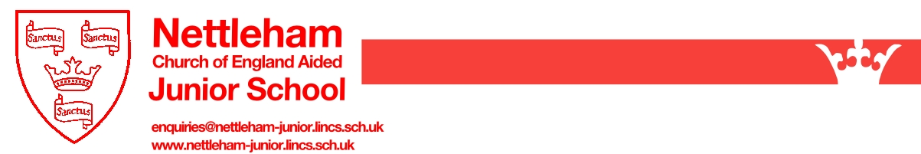

School Uniform Suppliers

Dear Parents/Carers,

We have 3 suppliers of our school uniform.

Price and Buckland (online only):
www.pbuniform-online.co.uk/nettleham

MyClothing.com (online only):
http://www.myclothing.com

Uniform Direct (online and physical shop)
https://www.uniform-direct.com/
Dixon House, Dixon Way, Lincoln LN6 7XN

Yours sincerely,

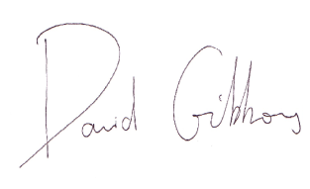

Mr. D. Gibbons
Headteacher

