Harvest Festival
17th October 2022
Donations please between 10th and 14th October
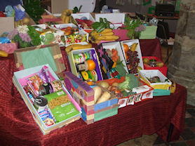
A quick reminder that our Harvest Festival is planned for the afternoon of Monday October 14th at 2.15pm at All Saints Church Nettleham. This is always a wonderful opportunity to celebrate as a whole school and all are welcome.
We welcome contributions of harvest produce, indeed it is an extremely important time of year to allow us to both give thanks and raise our own awareness of the needs of others. Therefore the more generous you can be…
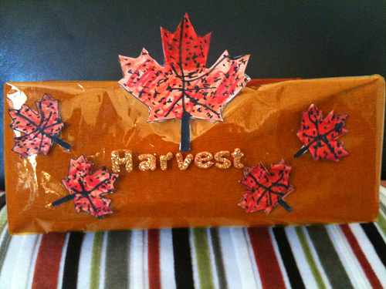
We would, once again, encourage you to spend some time decorating a box with the children to hold your contributions. It really does brighten up the church and I know that it gives a real lift to the charities who receive the produce. Please send your produce into school between Monday 10th and Friday 14th October.
In terms of what could be donated, Lincoln Community Larder have the following guidance, we hope that it helps plan your harvest box:
“Tins of: FRUIT, Rice Pudding, Tuna, Meats – (eg stews, meatballs, curries, hot dogs) Peas, Carrots, Sweetcorn. ‘Weetabix’ or own brand equivalent, Instant Coffee, Sugar, Jam, Pasta sauces. Semi-skimmed UHT milk. Instant Mash, Biscuits.
We are happy to take soap, shampoo, disposable razors, deodorants, handy packs of tissues, toothbrushes, toothpaste and sanitary items.”

