Church in the Porch
Sunday 10th January –1st Sunday of Epiphany

Jesus is baptised
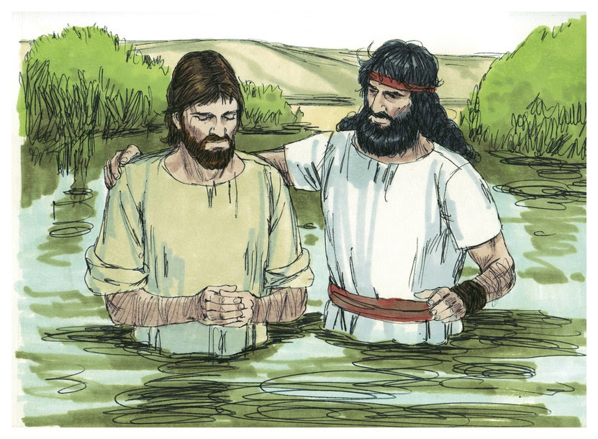

Gospel of Mark
Chapter 1, verses 4-11

www.asn.church
Our reading from the Gospel this week…
Jesus Is Baptised
At that time Jesus came from the town of Nazareth in Galilee to the place where John was. John baptised Jesus in the Jordan River. When Jesus was coming up out of the water, he saw heaven open. The Holy Spirit came down on him like a dove. A voice came from heaven and said: “You are my Son and I love you. I am very pleased with you.”
The International Children’s Bible (Mark 1: 9-11)

Something to think about…
When I was little I loved my mother’s special keepsake box. In there I would find a tiny expanding silver bangle which (until I was about 8 or 9) I could just about get onto my wrist if I squeezed all my fingers together very tightly.
It was a baptism gift from a great aunt when I tiny. I was baptised with my new baby sister. It is something that people always used to do with all their little children, but now mums and dads might decide not to do it at all, or to do something different. Perhaps you could ask your family - were you baptised?
Why did John baptise Jesus?
Long ago, people believed that if you were baptised you were made clean not just of dirt, but of bad things that you had done too. It was a way of saying ‘I’m sorry’ to God.
John didn’t want to baptise Jesus. In fact when St. Matthew tells us the story, John says ‘No, Jesus, it should be you baptising me!’ But in the end he baptises Jesus just like he was baptising all the other people. He said to them all – ‘say sorry for the things you have done wrong, because God’s Kingdom is coming!’ John doesn’t say this to Jesus (because Jesus didn’t need to say sorry). But Jesus did need to be baptised - because God had something to say instead!
Today, when someone is baptised, we have a special church service, and lots of family and friends are invited. Some people call it a ‘christening’. It’s a very special occasion when you are welcomed into the family of the church.
Baptisms happen in different ways in different churches. Some churches even have a big pool and dunk you under, just like the picture of John baptising Jesus on the front cover this week! At All Saints we baptise people – babies, children and grownups - at our font, into which we place a bowl of warm water.
Fr. Richard or Rev. Judy carry out the special service. There are lots of prayers, and then they make the sign of the cross on your forehead with some precious oil. And then they bless and pour the water over your head – once, twice, three times – in the name of the Father, and of the Son, and of the Holy Spirit! After that, they may sprinkle some water all over everyone else who has come to church as well!!
At your baptism, you will have some ‘godparents’ chosen for you. They are Christians invited to the service to promise that they will help you all through your life to know Jesus and love God. With their promises, the promises of your new church family, and the promises of God, you are claimed for Jesus. It’s a wonderful day, as we thank God for the wonderful gift that is you.

Rev. Teena

Saying sorry with water…a prayer activity
You will need:
Think of something that you want to say ‘sorry’ to God for and use the washable felt tips to write it down on the piece of plastic.
Now ‘baptise’ your plastic sheet, by dunking it in the water. As you lift it out, the washable pen will come off. Whatever you needed to say sorry for – God has heard you and you are forgiven by him.
Now dry the sheet with the kitchen roll and write on it ‘You are my child and I love you’ with the permanent marker pen.
Dip that into the water…what happens?
God’s love is never washed away!
A piece of clear plastic
Some washable felt tips
A permanent marker pen
A large bowl of warm water
A few sheets of kitchen roll
Things to do…
Baptism of Jesus colour and craft: Colour in the pictures then cut them out. Cut the straight and wavy lines in the big picture and weave the smaller picture through to baptise Jesus in the water!
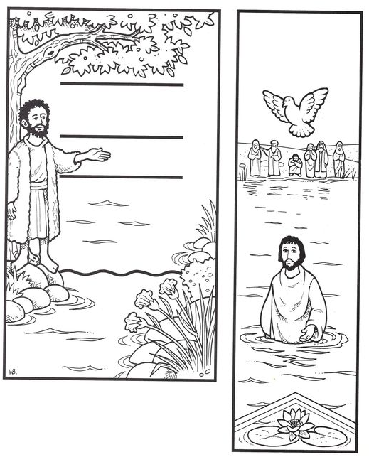
Word pairs: Each of these word pairs comes from our Gospel story or ‘Something to think about’ and the words begin with the same letter. Can you find them all?
J
W
_ _ _ _ _ _ _ _ _ _ _ _
_ _
_ _ _ _ _ _ _ _
B
_ _ _
G
_ _ _ _ _ _ _ _ _ _ _
_ _
F
_ _ _ _ _
_ _ _
C
_ _ _ _ _ _
_ _ _
H
_ _ _ _ _ _
_ _ _ _
S
_ _ _ _
_ _ _ _ _ _ _ _ _
P
_ _ S _
_ _ _ _
_ _ _
_ _ _
_ _ _
_ _
_
Prayers for this week…

Heavenly Father

At the Jordan you revealed

Jesus as your Son.

May we recognise him as our Lord

And know ourselves to be your beloved children

Through Jesus Christ our Saviour.

Dear God

When I do wrong

Help me to put it right.

When I say something bad,

Help me to say sorry.

When I am hurt by someone

Help me to forgive them,

As you have forgiven me,

Through Jesus Christ, our Lord.

Amen.

And a prayer of praise – you can hear this sung online at:

https://www.youtube.com/watch?v=8hyBJwTKmQ8

I love you, Lord

And I lift my voice

To worship you

O, my soul rejoice!

Take joy my King

From what you hear

May it be a sweet, sweet sound

In your ear!
Colouring page…

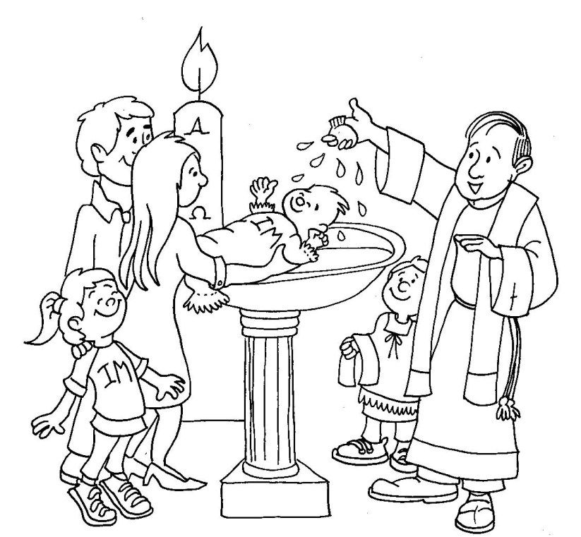
Parents’ page…
Further information on church activities and contact details for the ministry team are available at www.asn.church. We’re currently unable to hold our AllSaints@4 services in church. But you are still welcome to join us for worship anytime: by booking to join one of our Sunday 10am services in church (one weekly service is continuing during Tier 4 restrictions) by emailing admin@asn.church; or watching on our Facebook page (search All Saints Nettleham). We will continue to put resources for children and families in the church porch on Sundays and family worship resources on our website/Facebook page every fortnight whilst the Tier 4 restrictions are in place. As soon as we can safely gather, we will!

We would love to bring children forward for Baptism/Christening and first communion in 2021, hopefully from Easter time. We hope that this will be a time of real celebration – and that we will be able to gather in church in person by that time to see it all happen. If you would like your child to be baptised or to be admitted to holy communion, or would like further information then please feel free to contact Fr. Richard (rector@asn.church) or Rev. Teena (teena@asn.church) for a chat.

What do you think of Church in the Porch?

Please let us know – it’s really easy!
Just pop one of the ‘traffic light’ tokens into
the plastic pocket on the notice board in the
church porch. That’s it!

