[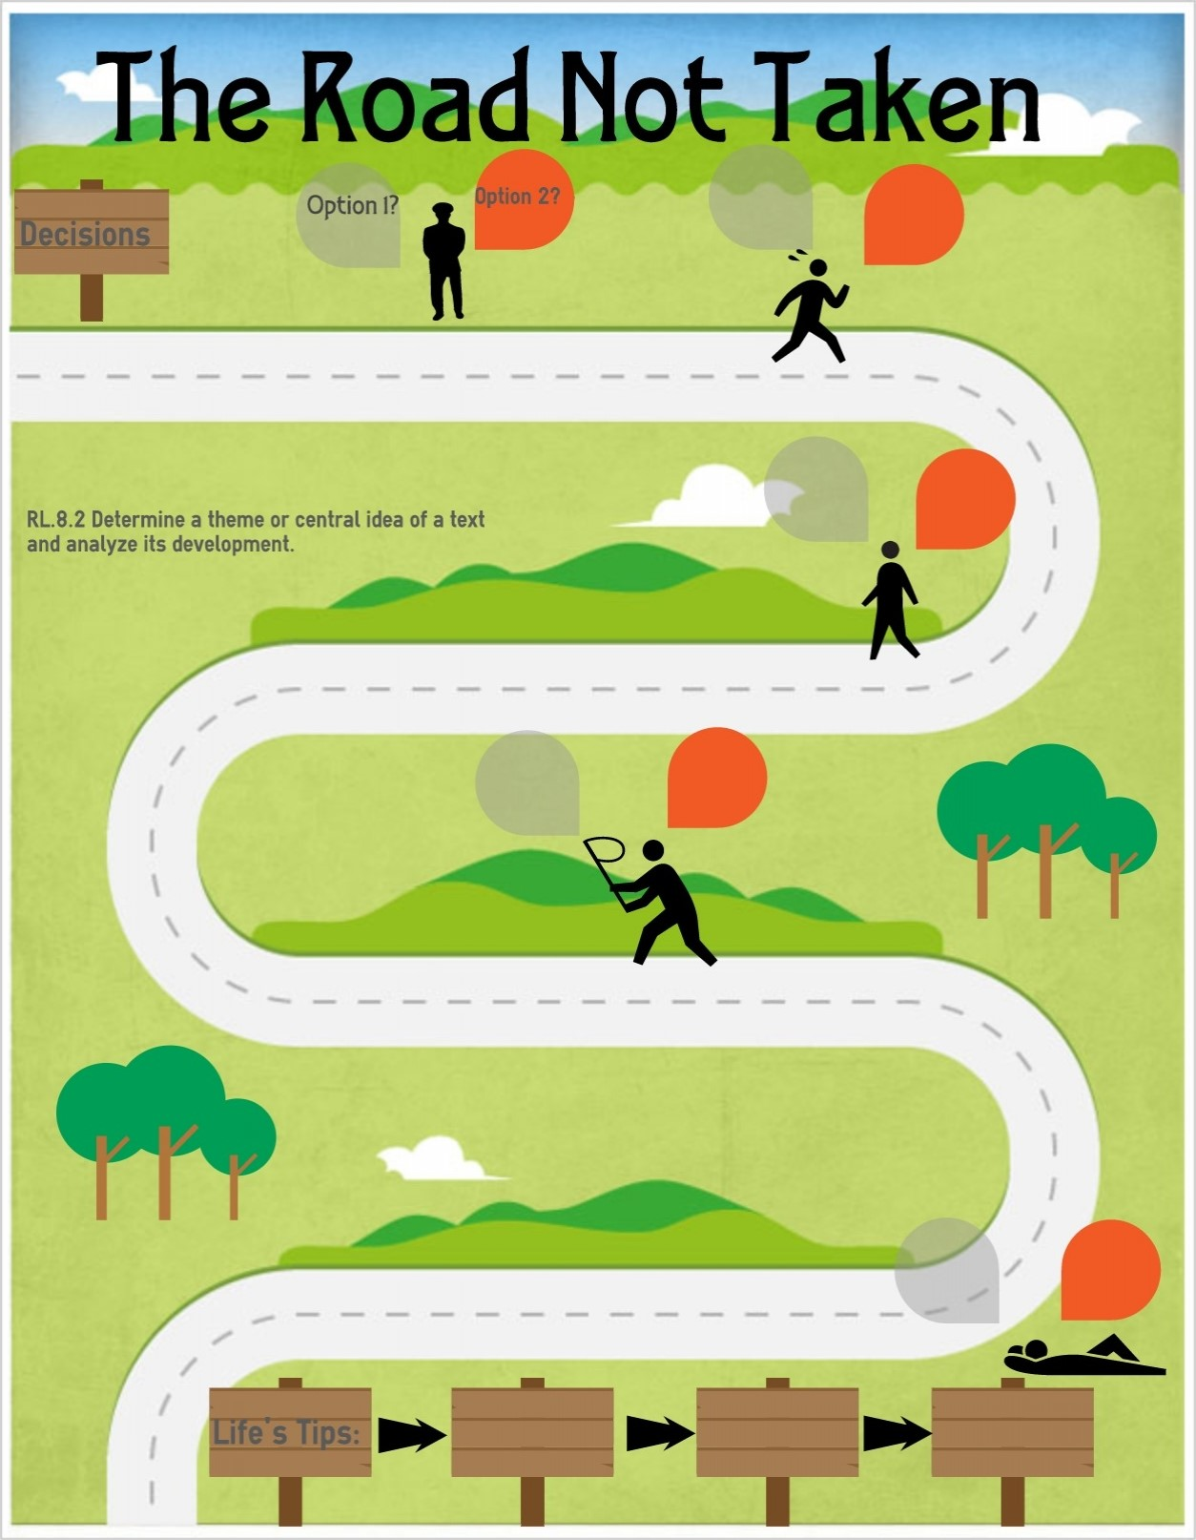](https://www.google.co.uk/url?sa=i&url=https%3A%2F%2Fwww.easel.ly%2Fblog%2Fspotlighting-the-reading-literature-standard-2%2Fimage3-2%2F&psig=AOvVaw3kz7SIqO8-5zpS1PMo6LEK&ust=1594810659830000&source=images&cd=vfe&ved=0CAIQjRxqFwoTCODYpIDLzOoCFQAAAAAdAAAAABAK)

PSHE Themes:

(HeartSmart)

-Get HeartSmart

-Don’t forget to let love in!

-Too much selfie isn’t healthy!

-Don’t rub it in, rub it out

-Fake is a mistake

-‘No way through’ isn’t true

Caring Friendships

*Pupils should know…*

–how important friendships are in making us feel happy and secure, and how people choose and make friends

–the characteristics of friendships, including mutual respect, truthfulness, trustworthiness, loyalty, kindness, generosity, trust, sharing interests and experiences and support with problems and difficulties

-the healthy friendships are positive and welcoming towards others, and do not make others feel lonely or excluded

–that most friendships have ups and downs, and that these can often be worked through so that the friendship is repaired or even strengthened, and that resorting to violence is never right

-how to recognise who to trust and who not to trust, how to judge when a friendship is making them feel unhappy or uncomfortable, managing conflict, how to manage these situations and how to seek help or advice from others if need

-Complete a basic outdoor problem solving challenge

Being safe

*Pupils should know…*

-that each person’s body belongs to them, and the differences between appropriate and inappropriate or unsafe physical, and other, contact

-how to recognise and report feelings of being unsafe or feeling bad about any adult

Can cross a road safely

Be discerning in evaluation digital content

Online relationships

*Pupils should know…*

–that people sometimes behave differently online, including by pretending they are someone they are not

–the rules and principles for keeping safe online, how to recognise risks, harmful content and contact, and how to report them

-how information and data is shared online

Cyberbullying

Use technology safely, respectfully and responsibly; recognise acceptable /unacceptable behaviour; identify a range of ways to report concerns about content and contact

Respectful Relationships

*Pupils should know…*

–practical steps they can take in a range of different contexts to improve or support respectful relationships

–the conventions of courtesy and manners

–the importance of self-respect and how this links to their own happiness

–that in school and in wider society they can expect to be treated with respect by others, and in turn they should show due respect to others, including those in authority

–what a stereotype is, and hoe stereotypes can be unfair, negative or destructive

-Understand and respect differences and diversity

Families and people who care for me

*Pupils should know…*

-that families are important for children growing up because they give love, security and stability.

-how to recognise if family relationships are making them feel unhappy or unsafe, and how to seek help or advice from others if needed

YEAR 3 – RSHE Road Map

Relationships Education